Week Beginning 29.6.20 Reception Home Learning

Hot climate Animals!
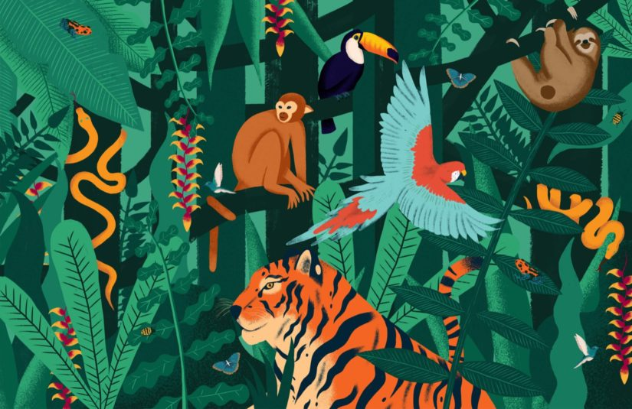

Monday

English
This week we are going to look at animals who live in the jungles and deserts of hot countries. We're going to start by reading (or watching) Rumble in the Jungle by Giles Andreae. Then today is our handwriting day. First look at the Letter Formation Posters again (no need to print these out). We have now looked at all of the four letter groups, so today we're going back over the curly caterpillars - as this is the one which we find the trickiest! Practise these letters, using the Curly Caterpillars sheet or just using lined paper to write your own.

Phonics
Start by watching the Phase 3 tricky words video again. Go to Polly's Phonics path on espresso. Read along all the sounds, click on any that you are unsure of along the way. Afterwards play the Reading (air, er, ture) game on espresso.

Maths
This week we are going to have a 3D shape focus in our maths lessons. First go through the 3D Shapes Powerpoint then carefully colour the shapes on the Colour 3D Shapes activity. Topic First watch the elephant video from cbeebies to find out a little more about elephants. Monday afternoon is our computing afternoon. Go to the elephant activity on Purple Mash (Art, Animals, elephant). Today you can be as creative as you like - design your own multi-coloured elephant! Don't forget to save your picture in our Reception folder. 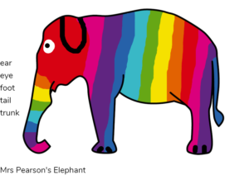

Tuesday

English
Re-read or watch Rumble in the Jungle by Giles Andreae. Think about all the different animals in the story, which jungle animal do you like the best? Then we are going to create our own list of animals from the story - try and draw and label at least five animals from the story, using either the Rumble In The Jungle List sheet or just a blank piece of paper. Have a look at the Rumble In The Jungle Word Mat to give you an idea.

Phonics
Start by doing the Flash Cards activity on Phonics Play (the link might work, if not it's just because you need to log in to Phonics Play first). Select Phases 2 and 3 and again make a note of any sounds your child is not yet confident with to practise on throughout the day. Then play the Segmenting (air, er, ture) game on espresso.

Maths
Start by watching the 3D shape song and then look through the 3D Shapes Everyday Object Powerpoint. Next do the 3D Shape Sorting Activity, sorting the everyday objects into the shape group that they best fit.

Topic
Start by watching the Animal Boogie Song. Then we're going to practise our cutting skills by making our own spiral snakes! Use the Snake Cutting Skills sheet or just draw your own outline on a piece of paper. First colour/decorate your snake then cut very carefully along the black line to create your own snake!

Wednesday

English
Read or watch Monkey Puzzle by Julia Donaldson. Have you ever read this story before? Use the Monkey Puzzle labeling sheet to write the correct name for each animal at the side of their picture.

Phonics
First watch the Phase 3 sounds video, this one focuses on ur, ow and oi. Then go to the Polly's Phonics activities section on espresso and choose any of the games there - depending upon which particular sounds your child is least confident with.

Maths
First watch the the 3D shape song then we're going to practise making patterns out of 3D shapes. Use the 3D Shape Repeating Patterns sheet or just create your own patterns using 3D shapes for your child to continue.

Topic
In very hot countries, it is like being in Summer all the time. Would you like to live somewhere like that? Watch the warm weather video on espresso. What kind of clothes do we wear in Summer to keep us cool? Do the Sorting: weather and clothes activity on espresso.

Thursday

English
Re-read or watch Monkey Puzzle by Julia Donaldson. Then we're going to use the Jungle Writing Picture to write simple sentences about what we can see in the jungle picture. The focus is on leaving a finger space between each word as well as letter formation.

Phonics
First watch the Phase 3 sounds video. This one focuses on air, ure and er. Then go back to the Polly's Phonics activities section on espresso and choose any of the games there - depending upon which particular sounds your child needs more practise with.

Maths
First watch the the 3D shape song again and then we're going to make our own 3D shape! Use the Cube Net sheet (or just draw your own). Choose 6 different animals and write or draw one animal on each face of the cube. Then (with a little bit of adult help) you can make the sheet into a cube and use it to do some funny animal actions! Here is an example: 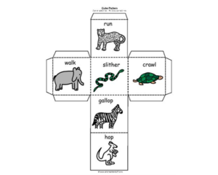

Topic
Thursday is our creative afternoon! First watch the Animal Boogie Song then we're going to get creative. Choose a jungle animal that you'd like to make - and make it out of anything you like! Here are some ideas to get you started:
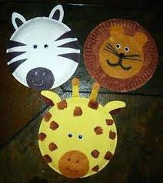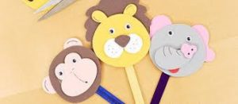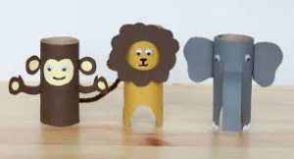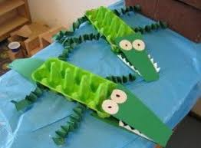

Friday

P.E.
Start by watching the Animal Boogie Song, then today's Cosmic yoga is a Jungle Safari Adventure!

Phonics
Start by doing the Flash Cards activity on Phonics Play (you will need to log in to Phonics Play to get it to work). Select Phases 2 and 3 and again make a note of any sounds your child is not yet confident with to practise on throughout the day. Then play any of the phase 3 games in the Polly's Phonics activities section on espresso to finish.

Forest Fun
Today we're going to go outside and go on a scavenger hunt! Use the Scavenger Hunt sheet (or create your own version using the sheet here as an example). Can you find everything on the list? Please send us photos so that we can see what interesting things you can find!

Topic
Friday is always our finishing off/catch up/intervention time. If there is anything your child has not managed to do yet or you feel would benefit from going over again, please use this time to do so. Also, please make sure that they are forming all of the letters in their name correctly!
Have a lovely weekend 😊

