Week Beginning 6.7.20 Reception Home Learning

Animal Fantasy Stories!
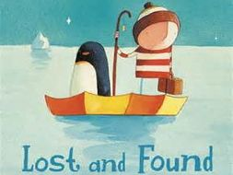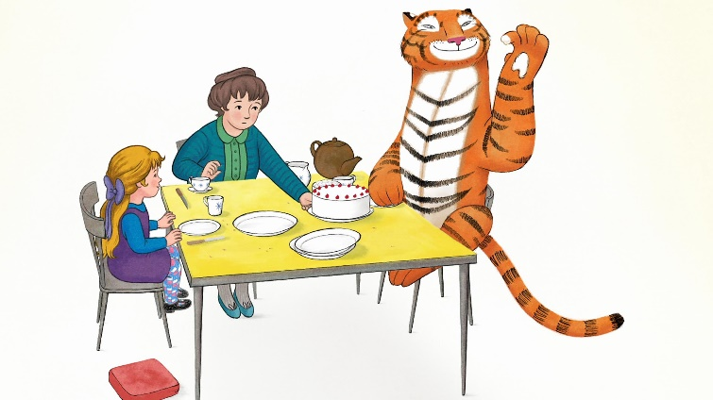

Monday

English
We're going to start with our first story of the week: Lost and Found by Oliver Jeffers. Have you read this story before? What do you like about it? Then today is our handwriting day. First look at the Letter Formation Posters again (no need to print these out). We have now looked at all of the four letter groups, so today we're going back over the 'One Armed Robot letters'. Practise these letters, using the One Armed Robot Letters sheet or just using lined paper to write your own.

Phonics
Start by watching the Phase 3 tricky words video again. Go to Polly's Phonics path on espresso. Read along all the sounds, click on any that you are unsure of along the way. Afterwards play any of the Polly's Phonics games on espresso, focusing on whichever specific sounds your child needs to practise the most.

Maths
This week we're going to go over numbers to 20 for one last time - to make sure we are super confident with them! Start with our Numbers to 20 song. Then we're going to practise ordering numbers to 20, using the Ordering To 20 Cut And Stick sheet (or just create your own version).
Topic
First watch the Let's go to the Zoo song together. Then Monday afternoon is our computing afternoon! Go to the My Animal activity on Purple Mash (Art, Animals, My Animal). Today you can be as creative as you like - now that it's coming towards the end of our animals topic we're each going to design our very own animal! Don't forget to save your picture in our Reception folder. 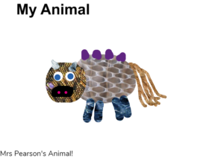

Tuesday

English
Start by re-reading or watching our first story of the week: Lost and Found by Oliver Jeffers. When the boy finds the penguin he wants to help but he doesn't know how. Pretend that we're all going to help the boy by making him some posters about the penguin to put up around his town! Use the Found Poster template or just use a blank piece of paper to create your own.

Phonics
Start by doing the Flash Cards activity on Phonics Play (the link might work, if not it's just because you need to log in to Phonics Play first). Select Phases 2 and 3 and again make a note of any sounds your child is not yet confident with to practise on throughout the day. Then play any of the Phase 3 games on Phonics Play - focusing upon whichever sounds your child needs to practise most.

Maths
Start with our Numbers to 20 song again. Then we're going to practise writing the numbers to 20, first by watching the Writing Teen Numbers song and then using the Number Formation 11-20 sheet, or simply writing your own out. Remember that all number start at the top... and those number 8's should be done in one movement (starting with a 's' shape), not two separate circles!

Topic
We're going to think about the special friendship of the two main characters in our Lost and Found story. Watch Barney's Friendship song and then think about your own friends. Who is your best friend and why? Complete the My Best Friend sheet (or create one of your own).

Wednesday

English
First we're going to start with our next story of the week: The Tiger Who Came to Tea by Judith Kerr. Have you read this story before? Would you like a tiger to come to tea at your house?! Look at the picture of Sophie and the tiger on the Sophie Speech Bubble page. Discuss what Sophie might be saying. Use your phonics skills to write it down inside the speech bubble!

Phonics
First watch the Phase 3 tricky words video . Then go to the Polly's Phonics activities section on espresso and choose any of the games there - depending upon which particular sounds your child is least confident with.

Maths
Start with a numbers to 20 song. Then we're going to play the Helicopter Rescue game on the Topmarks website. There are lots of different options, please choose: Find a Number, Direct and 1-20. If they do well with this you can always challenge them by trying the 'In Between' version afterwards.

Topic
First watch and listen to The Tiger Who Came to Tea song. Then we are going to think about ourselves. If we could have any animal pop round to our house for tea, which animal would you choose and why? Use the The Tiger Who Came to Tea Guest sheet, or just use a blank piece of paper to draw the animal that you would love to have round for tea and then explain to a grown up why you think it would be fun!

Thursday

English
Start by re-reading or watching The Tiger Who Came to Tea by Judith Kerr. Today we're going to look carefully at pictures from the story which are all muddled up and in the wrong order. Can you cut them out and put them back into the correct order? Use the Sequencing Pictures sheets (or draw simple versions of the pictures yourself).

Phonics
Start by doing the Flash Cards activity on Phonics Play (you will need to log in to Phonics Play to get it to work). Select Phases 2 and 3 and again make a note of any sounds your child is not yet confident with to practise on throughout the day. Then play any of the phase 3 games in the Polly's Phonics activities section on espresso to finish.

Maths
Start with a numbers to 20 song. Then we're going to look at representing numbers to 20 in different ways. In school we use the Numicon pieces a lot in our maths lessons. Use the Number Representation And Formation 11 to 20 sheets, to practise looking closely at the pictures of the Numicon pieces and working out which numbers they represent.

Topic
First listen to the Robbie Williams version of The Tiger Who Came to Tea song (this is from the new film version of The Tiger Who Came to Tea which was released at Christmas time and we will be watching at some point in school this week, please do so at home if you are able to get it, don't worry if not!). Then Thursday is our creative afternoon: Use whatever you like to make your very own tiger - it could be junk materials, paint, play-dough, Duplo, Lego, fabric - whatever you like! Once you've made your tiger send us a photo on Tapestry so that we can see - and then maybe your tiger could join you for tea today! 🐅🐅🐅

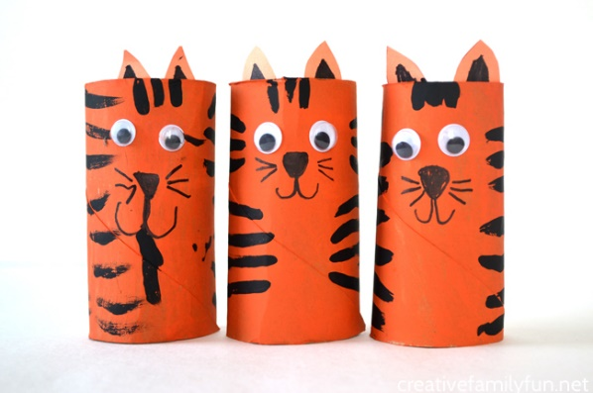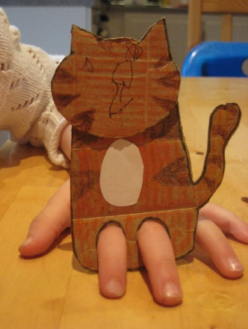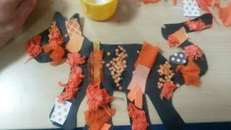

Friday

P.E.
Start with a sing and dance to the Animal Sounds song, and the Let's go to the Zoo song then it's Cosmic Yoga time: Twilight The Unicorn of Dreams!

Phonics
Today we're going to check that we're confident with all of the Phase 3 sounds on Polly's Phonics - and if so they will earn their certificate! First, ask your child to read along the Polly's Phonics Path. If they need to practise some of the sounds that's absolutely fine - let them watch the videos etc. and then try reading along the path again. If they manage all the way along then they definitely deserve their certificate! -Don't worry if not though, use this afternoon's time to focus on this activity (and continue next week if necessary) and just give them their certificate whenever they deserve it! 😉

Forest Fun
As today is our last Forest Fun session of the year, we want the children to go outside and just have a great time being out in nature! If it's raining go and have fun splashing in the puddles, if it's sunny go and search for beautiful flowers and minibeasts or roll down a grass banking! Make sure you fit a game of hide and seek in ... and above all else just have fun!

Topic
Friday is always our finishing off/catch up/intervention time. If there is anything your child has not managed to do yet or you feel would benefit from going over again, please use this time to do so. In particular, if your child struggled with any of the Phase 3 sounds please practise these this afternoon so that they can get their certificate!
Have a lovely weekend 😊

