w/b 13.7.20

Hi Year 1,

The summer holidays are almost here! 🤩 ☀️ 🤩 It is hard to believe that it is now the last week of term and this is your last week in Year 1! 😢

Over the past few months, school has not been the same without you all but we would like to say how incredibly proud we are of how well you have done 🏆 ... it has been lovely keeping in touch on Tapestry and it has been great to see and hear all the lovely things you have been up to. 😊 😊 😊

It is a bit sad that we will not be together in person this last week but hopefully our ZOOM PARTY will make up for that! The children in school are SO excited about it and are really looking forward to seeing all their friends again - we are sure it's the same for all of you at home too! 🎉 🥰 💃🕺It would be brilliant if you could all join us - we have had quite a few replies so far. 🥳 *Please check Tapestry for details*.

On party day, don't forget to dress up ... we've already heard about some of your fabulous outfit ideas!!! At the party, you can share a little message with us if you wish, or you can just show us the picture you have made if you prefer ... how much you would like to join in really is up to you 😊 Remember to practise the continents and oceans songs (details on Tapestry) ... the children in school now know them so well that we're sure they even sing them in their sleep! 😴 🌍 🎼 🐳

We are really looking forward to seeing you all again in September, when you will be grown-up Year 2s! We will be able to have some time together then, so we can have a proper catch-up and say a proper goodbye! 💫

For this final week, we want to reward you for all your hard work but we also recognise that you have missed out on our usual summer term activities e.g. summer fair, Friends of Buckstones treat day, sports day etc. so ....... we have have arranged lots of fun activities for you - see below for details.

Hope to see you all at the party on Wednesday (1.45pm). 🎉 🥰 💃 🕺

Lots of love from the Year 1 Team x x x

w/b 13.7.20
We have planned a fun-filled week for our final week in Year 1! Some of our activities are whole-school ideas; others have been suggested by the children we currently have in class with us. You may wish to choose from our ideas or instead create your own special days.
We have made a simple timetable of what our week in class will look like, but for those of you at home, we appreciate that you may have siblings in other classes, so you can choose what you want to do and when you want to do it ... the exception of course is our party on Wednesday afternoon!
* The only task we are asking all children to complete please are the transition activities - ‘All About Me’ / ‘Memories’ - ready for Year 2. *

Our week in class will look something like this:
 | morning | afternoon
Monday | All Around The World Morning 🌍 | Games Afternoon 🎲
Tuesday | Art & Craft Day 🌈
Wednesday | Transition Morning 🌟 | Year 1's Zoom Party! 🎉
Thursday | Sports Morning 🤸🏻‍♀️ | Quiz Afternoon 💡
Friday | Movie Morning 📽 | Picnic Afternoon 🍰

MONDAY

am - All Around the World Morning
For this one, we are following the lead of the children we have in class at the moment … they have said they would like to find out more about the continents we have not yet studied – Asia, North & South America and Europe. If you wish, you can find out more by watching Go Jetters and/or National Geographic Kids.
We have 4 different activities that we will be doing in class – feel free to do any of them too, if you wish.

Asia
Go Jetters: https://www.youtube.com/watch?v=h598k80U9qQ
National Geographic: https://www.youtube.com/watch?v=nsOtOye-DJM
** Our Asia activity in class will be to have a go at writing some Mandarin Chinese numbers. **
Mandarin Numbers 1 10 (don't worry about zero!)
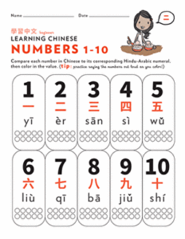

North America
Go Jetters: https://www.youtube.com/watch?v=VBJnPWLrni4
National Geographic: https://www.youtube.com/watch?v=AOUK3Oit86o
** Our North America activity in class will be to make our own New York skyscrapers. **
We will be doing a piece of artwork in class (see NYCskyscrapers.examples), but for those of you at home, you can build your own skyscraper if you prefer (e.g. out of Lego, Duplo, boxes etc.)

South America
Go Jetters: https://www.youtube.com/watch?v=YtyLtziGbrY
https://www.bbc.co.uk/teach/class-clips-video/pshe-eyfs-ks1-go-jetters-continent-of-south-america/zjrbf4j (Rio Carnival)
National Geographic: https://www.youtube.com/watch?v=R35URiT_fm8
** Our South America activity in class will be to make a mask for Brazilian Mardi Gras. ** Here are some templates if you wish to use them - Mardigras.mask Template / Design A Mask.templates .
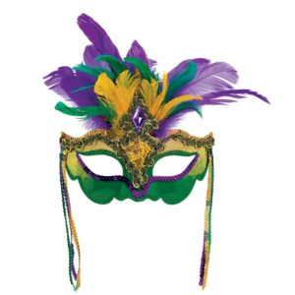

Europe
Go Jetters (BBC iPlayer): https://www.bbc.co.uk/iplayer/episode/m00086jl/go-jetters-series-3-6-the-continent-of-europe
National Geographic: https://www.youtube.com/watch?v=RNx0akt3_XI
** Our class activity for Europe will be to recreate a watercolour painting by Claude Monet – Water Lilies. **
See Monet Water Lilies. In class we will be using Purple Mash (and its special arty tools!) but it's also fine if you prefer to paint your own.
**See Purple Mash.Monet for login details and instructions.
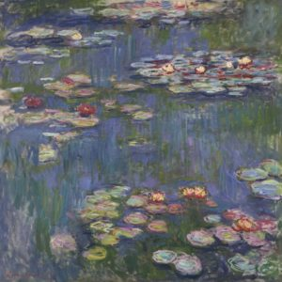

pm - Games Afternoon
How do you fancy spending this afternoon playing games with your family?
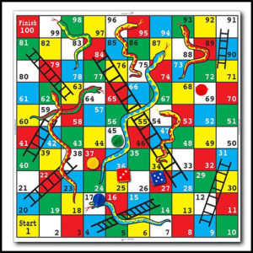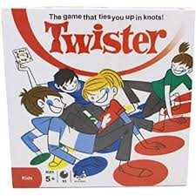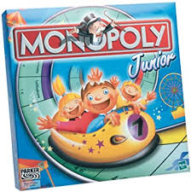

TUESDAY

Art & Craft Day Ideas
You can do whatever art and craft activities you wish today - there are lots out there to choose from!
Fingers crossed, the weather is getting better - just in time for us breaking up ☀️☀️☀️ - so here are some ideas for garden-related art and craft activities, should you wish to use them:
Art & Craft Examples Garden.recycling

WEDNESDAY

am- Transition Activities
We would like you to complete two activities for this, please.
- All About Me – some information to pass on to Mrs. Joyce. Don’t worry if you don’t have a printer – you can present your ideas however you wish e.g. as a poster, on the computer, as a letter / postcard. All About Me Poster
- Memories of this year – it has certainly been a strange year, but we thought it might be nice if you also came up with some lovely memories from your time in Year 1. Memories ** If possible, please could you take a photo of your child with these so that we can share them with Mrs. Joyce, ready for September.**

pm- It's party time!

🥳 🎈 🎉
Don't forget our zoom party at 1.45pm - see Tapestry for invitation and details.

N.B. Children in school - you will need to come to school in your own continents /oceans-themed clothes today.

THURSDAY
Let's get sporty this morning by engaging in some physical activities.
There are lots to choose from in the document below and whatever the weather we can still have lots of fun!

REMINDER: For children attending school, please come in wearing your Games Kit.
Outdoor No Contact Games And Activities

In the afternoon we can cool down by choosing a quiz or two to entertain us whilst having some fun. Who will be the winner in your household?
Here is the list to choose from:-
T E 2549691 Name That Story Powerpoint Quiz Ver 5
T T 2547951 Ks1 The Big End Of Year Animal Quiz Powerpoint Game Ver 3T T 2547932
Ks1 The Big End Of The School Year Picture Quiz Powerpoint Ver 1
Odd One Out Discussion Prompt

FRIDAY

Oh my goodness it is the last day of term!

REMINDER - If you attending school today, please wear your own clothes.
This morning get ready to settle down to watch a film. This can be of your own free choice ( U certificate).
Or, in keeping with the theme of continents, you could try the films;
Happy Feet, Frozen, Finding Nemo or Madagascar.
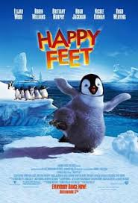
For our last afternoon we have planned in a picnic lunch for us all to enjoy outdoors (weather permitting) and if time another chance to play some games.

⭐️ Wishing you all a lovely summer holiday and many thanks for all your support this year! ⭐️

