HOME LEARNING
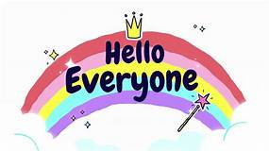
Hello everyone! We hope you are all well.

Important notice...

Reception are having an end of year Zoom party!
On Friday morning at 11am (17th July)

Log in details will be sent via Tapestry on Monday 13th July

We really hope to see you all there! 😊

Below you will find home learning activities for our Reception children. Remember these are just ideas of activities you can do. Everyone is different so please don't worry if you can't complete all of the activities. Also if you are unable to print work out please just answer the questions or do the activity in a work book or on paper.
Above all else, have fun with your learning and take care, From Mrs Pearson, Mrs Hall and Mrs Leavy :)

USEFUL WEBSITES
Here is a list of links to sites that we subscribe to and use in the Infants: Website Links For Infants You may have seen in the news that the Government are providing daily lessons for each Year Group, delivered by ‘The Oak National Academy.’ To access these, click on the link: https://www.thenational.academy/online-classroom/schedule You may want to dip in and out of these to supplement the work on our website. Remember, these are just suggestions for further ideas and they do not necessarily follow the same topics that we are covering at Buckstones. Please do not worry if you do not use them!

GENERAL ON-GOING DAILY ACTIVITIES:

PHYSICAL ACTIVITY
Daily exercise - get out in the fresh air if possible :) Try whichever physical activities your child enjoys most. These links may be useful: Dance Videos with Mrs K - dance with our very own Mrs Kulczycki! The Body Coach (Joe Wicks) has daily workouts that we are following in school. Cosmic Yoga has some lovely activities to try. The Real P.E. website has daily activities for each of the different key stages. Log in details have been sent to all parents via email. Oldham Sport Development are setting a daily challenge for all Oldham children, just visit @volsportoldham for updates.

READING
Please continue to read on a daily basis. Read books from home. Remember to record these in your reading records so that they count towards your child’s bookmark stickers. If you are struggling to find new age-appropriate reading materials have a look on the Oxford Owl website, there are plenty of free on-line books to access here. New reading ideas: Search for: Teach your Monster To Read and/or Jolly Phonics e-readers if you need new reading ideas. Continue to work through the Buckstones Reading Challenge and also practise reading the child's key words as often as possible. Please keep on sending any photographs in via Tapestry (rather than via email to the school office), it is so lovely to see the work that the children are doing at home - and we can add them to the Home Learning Experiences Page so that the children can all see each other too!

Week Beginning 13.7.20 Reception Home Learning
I can’t actually believe it, but this week is our last week of being in Reception! To reward the children who have been working so hard over the last few months (especially in such strange and difficult circumstances) we have decided to plan a special week of activities, including all the lovely fun activities that the children have missed out on lately. We really hope to give them a special last week of term. 😊
Below is the timetable of activities that we will be following in school. Please feel free to change the order of activities to whatever suits your family best (we are aware that several of our children have siblings in other year groups and therefore it would make sense for them to move things around to do certain activities together). The only time that is fixed in stone – and please save this date - is Friday at 11am as this will be our Reception end of year Zoom party… we really hope to see you all there! 🎉🎈🤩

 | Morning Activity | Afternoon Activity
Monday 13th July:  Transition to Y1 Day | We are going to work through the first few pages of the All About Me Booklet this morning; using our neatest writing and colouring, to show the Year 1 teachers how clever we are! | We are going to finish off the All About Me booklet this afternoon.  * Please bring your booklet with you on the first day of the new term to give to Miss Platt and Mrs. Tetlow. 👍
Tuesday 14th July:  Art & Craft Day | Today we are going to have lots of different rainbow themed arts and crafts out to choose from throughout the day. Here are some examples of the types of things we will be doing.  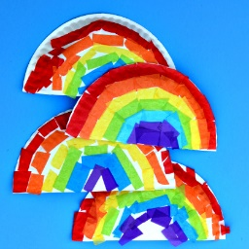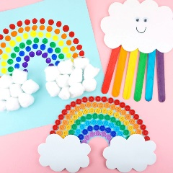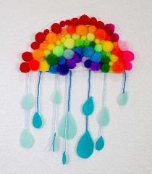  Please send us photographs of your own rainbows that you make at home!
Wednesday 15th July:  Movie Day | Help your grown-up make some nice snacks to eat with your movie! | Movie Time! We will be watching ‘The Little Mermaid’ in school (as we had planned to all do this just before lock down as part of our 'Under the Sea' topic).  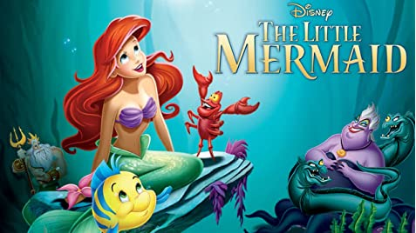
Thursday 16th July:  Sports Day  *Key worker children can wear ‘sporty clothes’ to school. | Different sports games and activities: There are lots of different sports activities you could try with your family – have a look at Twinkl Home Sports Day if you need any ideas or resources. | Cosmic Yoga and action songs time (we're going to choose our favourites from the last few months). Which ones will you choose?  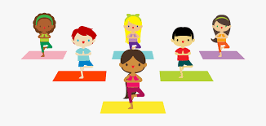
Friday 17th July:  Party Day!  *Key worker children can wear non-uniform to school. | We are going to start by decorating and making party hats using the Party Hat template sheet. 🥳  Then we're going to wear the party hats for the Zoom meeting at 11am: Meeting details will have already been shared with you on Monday morning (13th) via Tapestry! 🎉 | Party afternoon! 🥳 We will be dancing away to a few of our favourite songs and playing a few (non-contact) games too, such as ‘I Spy’ and animal riddles!  Above all else, today is all about having fun!

We are so proud of the children for working so hard and we have loved seeing photos of their home-learning on Tapestry. We miss the children more than you can ever imagine!

Thank you to all of you for your on-going support from home.

We wish you a very happy and safe Summer and we can't wait to see all the children again in September!

Best wishes, Mrs Pearson, Mrs Hall and Mrs Leavy xxx

