Useful Maths Websites – Year 1
Hit the Button – different number facts practice (halves, doubles, number bonds etc.), free for laptops but can also download an app for tablets / iPads (small fee)
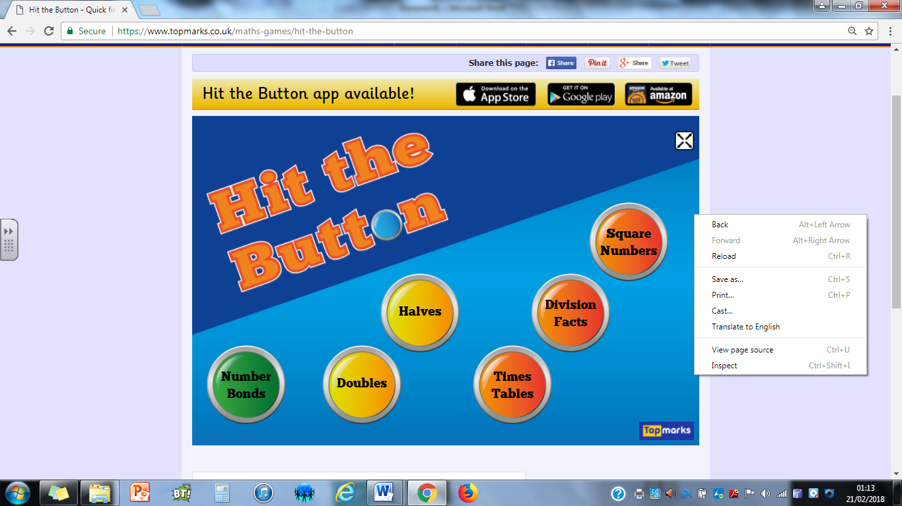
www.ictgames.com – a variety of maths activities, again free for laptops
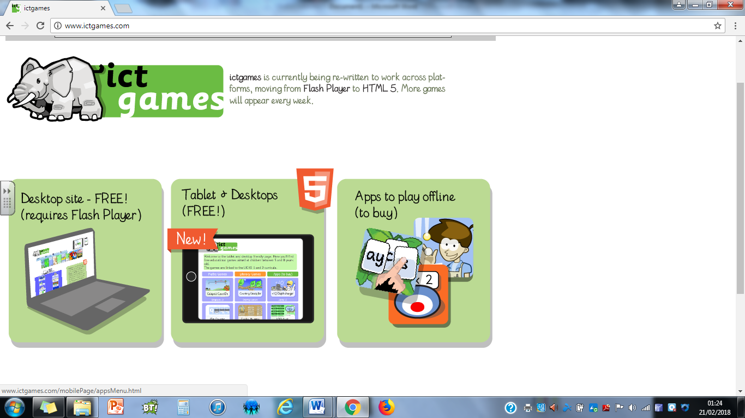
Funky Mummy / Funky Mummy 20 (ICT games) - practice of number bonds to 10 / 20
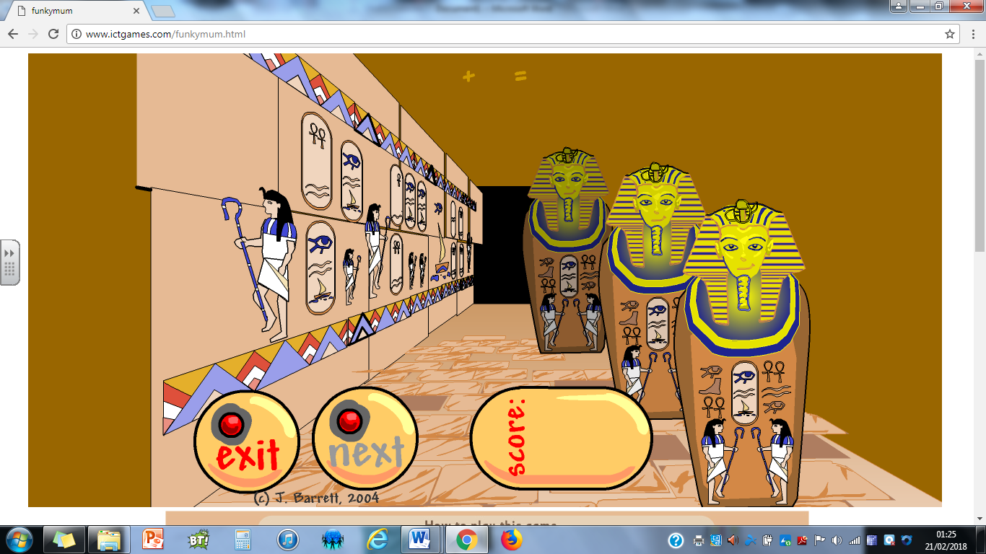
Paint the Squares – good for practising reading / finding numbers to 100 – read a number, ask your child to find it and ‘splat’ it. Also useful for splatting number patterns eg. counting in 5s, odd and even numbers, counting in 10s from any single digit number etc.
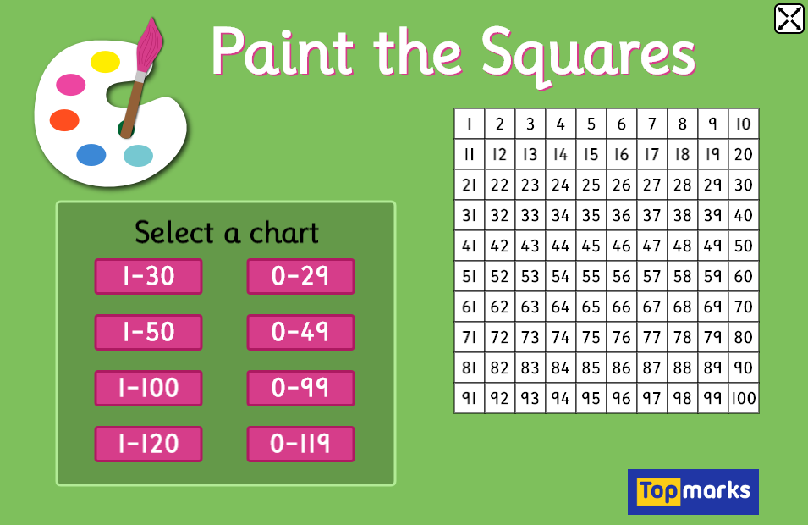
Various songs to practise counting in 2s / 5s / 10s – the children know which ones we do and have their favourites! eg. Scratch Garden, Have Fun Counting, Jack Hartmann etc. Beware – as they are American, they say ‘counting by …’ instead of ‘counting in …’ – they children know to correct them!
Hope you find these useful!

