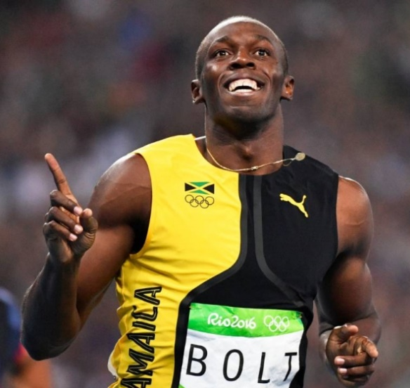
Usain Bolt – Biography
Have you ever seen the fastest man on the planet?
Usain Bolt was born on 21st August 1986, in Jamaica. As a child, he really enjoyed playing football and cricket. He took part in his first race whilst at primary school, however, at that time he preferred playing cricket. In an interview he once said that if he hadn't become a sprinter he would have loved to be a fast bowler like his cricketing hero Waqar Younis.
At high school he focused on sprinting and won his first silver medal in the 2001 High School Championships. His talent caught the eye of former Jamaican Olympic sprinter Pablo McNeil who went on to become his coach. Pablo would sometimes get frustrated with Bolt as he didn't always take his training very seriously and liked playing practical jokes.
In 2004, he became the first junior sprinter to run 200 metres in under 20 seconds. it was then that he turned professional and was given a place on the Jamaican Olympic team. He went to the Olympic Games in Athens in 2004 but a leg injury stopped him from winning any medals. Bolt was very sad about his injury fearing he wouldn’t get the chance to sprint again.
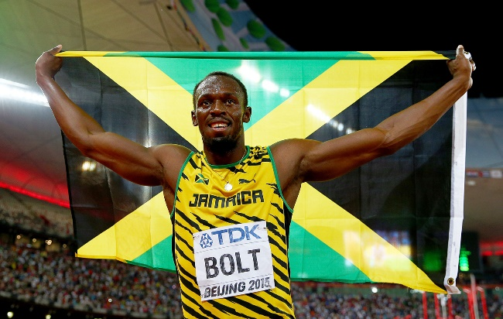
As the years passed by, Usain took his sport more seriously and began to train harder to win events. At the 2008 Beijing Olympic Games, he broke more world records and won gold in the 100 metres, 200 metres and relay events. This was followed by the World Championships in Berlin where he improved his times even more. During the 2016 Rio Olympics, Bolt again won gold in all three races (100 metres, 200 metres and relay).

In 2017, at the World Athletics Championships, Bolt’s success didn't continue. He won a bronze medal in one event and he collapsed on the track with a hamstring injury at another event and had to be helped across the finish line by his team mates. This was Bolt's final ever race.

