Wednesday 11th November 2020
W.A.L.T.: understand the structure of the human eye and how we see.

The Human Eye

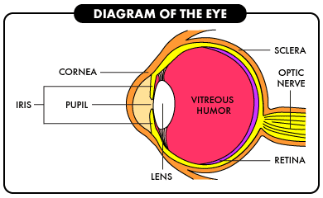

________________________________________________________________________________________________________________________________________________________________________________________________________________________________________________________________________________________________________________________________________________________________________________________________________________________________________________________________________________________________________________________________________________________________________________________________________________________________________________________________________________

Use the following words to label your diagram:
sclera cornea lens optic nerve iris pupil
retina vitreous humour
Find out what the function is of these different parts of the human eye.

