www.phonicsplay.co.uk
See Y1 homepage for login details

Fri.3/ng
* We are learning a new phoneme ng and how to read and write it.*

Warm-up –
Start by logging onto Phonics Play.
Flashcards (Time Challenge) - time to practise our phonemes again!
https://www.phonicsplay.co.uk/resources/phase/3/flashcards-time-challenge
*Grown-up – please choose 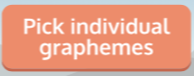 then Sets 5, 6, 7 and 8. Thanks!*
How did you get on?

New Phoneme: ng
Please watch the Little Learners ng lesson. Practise your blending to help you read the words.
https://www.youtube.com/watch?v=Nrjb0rIer5M

Task 1 – On Phonics Play, play Make a Match (Phase 3, Weeks 3) to practise this week’s phonemes. It’s a test for your memory as well as your phonics!!!
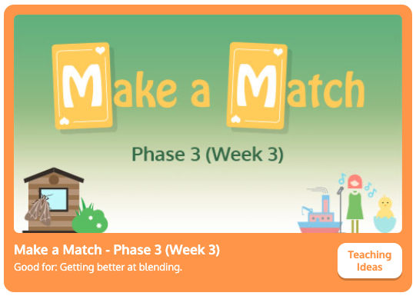
https://www.phonicsplay.co.uk/resources/phase/3/matching-ph3w3

Task 2 – Sound-talk these words:
sing ring king bang long
Ask an adult to read these sentences aloud. Can you write them in your book? Underline the ng words.
- I can ring.
- I can bang.
- I can sing a song.

Well done Kippers – Keep up the good work!

