www.phonicsplay.co.uk
See Y1 homepage for login details

Mon.3/wh

Warm-up (revision) – Log onto Phonics Play - Tricky Word Trucks https://www.phonicsplay.co.uk/resources/phase/4/tricky-word-trucks
Click on (these words are familiar). Follow the instructions. How well did you do – did you get them all right?

* We are learning a new grapheme wh and how to read and write it.*
How many words can you think of that contain ‘wh’? Make a note in your book of all ‘wh’ words you come up with. Highlight the wh in each word – what do we notice about where it is? (i.e. at the start)

Task 1 – Can you read these wh words?
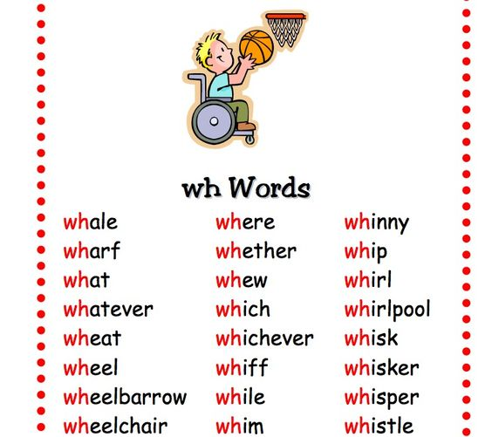
Again, where is the wh in each word? (i.e. at the start!) Do you know what all of these words mean? Find out the meaning of any words you are unsure of.
Task 2 – Read the words on the Questions poster … what do you notice about most of them? Which is the odd one out? (5/6 start with wh, so the odd one out is how).
Can you think of a question for each of the question words? No need to write them down, instead say them out loud to somebody else. e.g. What time is it?
Well done Biffs – keep it up!

