www.phonicsplay.co.uk
See Y1 homepage for login details

Thurs.3/oe (toe) & ou (shoulder)

* We are revising the grapheme oe (as in toe) and learning a new grapheme ou (as in shoulder).*
We know ‘ou’ makes an ‘ow’ sound (e.g. now, clown) but it also makes an ’oe’ sound (e.g. shoulder, boulder).
Watch Letters and Sounds lesson: oe (toe) / ou (shoulder)
https://www.youtube.com/watch?v=yKMkkCbdOR4&feature=youtu.be
You will need a pencil and your book because part-way through you will be asked to write some of your words down.
Let’s practise this mnemonic to help us to remember how to spell the tricky word because?
big elephants can always understand small elephants
Write because (and the mnemonic) in your book. Draw a picture as another clue!
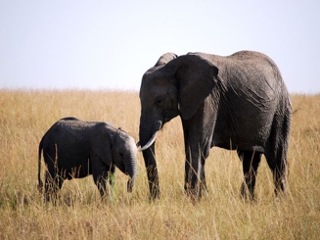 Well done Biffs – keep it up!

