www.phonicsplay.co.uk
See Y1 homepage for login details

Tues.3/ch
* We are learning a new phoneme ch and how to read and write it.*

Warm-up –
Start by logging onto Phonics Play.
Warm up your brains time – let’s play Grab a Giggling Grapheme. Press Start, then click on. You’ll need to listen carefully!
*Grown-up – please press Start then choose Thanks!*
Did you get them all?

New Phoneme: ch
Please watch the Little Learners ch lesson on. Practise your blending to help you read the words.
https://www.youtube.com/watch?v=mGSFG37LewA

Task 1 – Can you read these ch words? Use the sound buttons to help you:
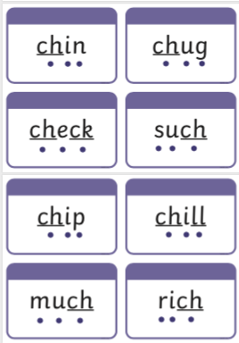
Task 2 – Now complete the sh or ch activity – sheet on website (Tues. Phonics. Kippers). It can be done on the sheet or in your book.
Well done Kippers – Keep up the good work!

