www.phonicsplay.co.uk
See Y1 homepage for login details

Weds.3/key words – we / me / be
* We are learning a new phoneme ch and how to read and write it.*

Warm-up –
Let’s practise the alphabet song again. Sing the song, pointing to each letter as you sing.
https://www.youtube.com/watch?v=ycnPbp_CrVg
Now carefully copy the letters into your book in your best handwriting. How many do you have altogether? You should have 26!

New tricky words: we / me / be (he /she)

Task 1 – log onto Phonics Play
https://www.phonicsplay.co.uk/resources/phase/3/train-your-brain-ph3

Follow the instructions:
- Introduction 2. Demonstration 3. Choose words:
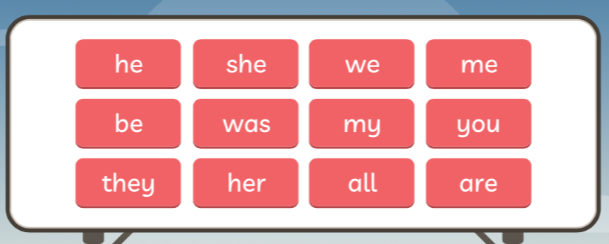
You need the first 5 words (he, she, we, me, be)

Task 2 - Read these words:
we me be
he she
What do you notice about them? (They all end in -e … notice how it is -e, not -ee).
Now write the words carefully into your book.

Well done Kippers – Keep it up!

