www.phonicsplay.co.uk
See Y1 homepage for login details

Fri.4/oa
* We are learning a new phoneme oa and how to read and write it.*

Warm-up –
Start by logging onto Phonics Play.
Flashcards (Time Challenge) - time to practise our phonemes again!
https://www.phonicsplay.co.uk/resources/phase/3/flashcards-time-challenge
*Grown-up – please choose then Sets 7 and 8 (all). Thanks!*
How did you get on?

New Phoneme: oa (2 letters, so it’s a digraph)
Please watch the Little Learners oa lesson. Practise your blending to help you read the words.
https://www.youtube.com/watch?v=M8nGaspuWAQ

Task 1 –Have a look at the oa pOWERpOINTDOC. Each slide shows an oa word. Can you work out what the oa words are?
Click Slide Show, then Play from Start:
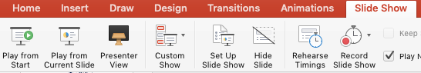
Task 2 – Look at the pictures of the oa words. Can you say what each oa picture is?
1. | 2. | 3. 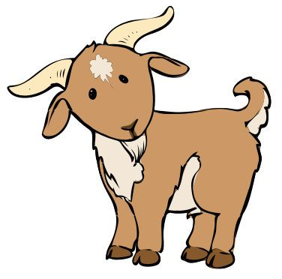
4. 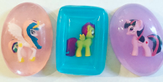 | CLUE - I’m not a frog!  5.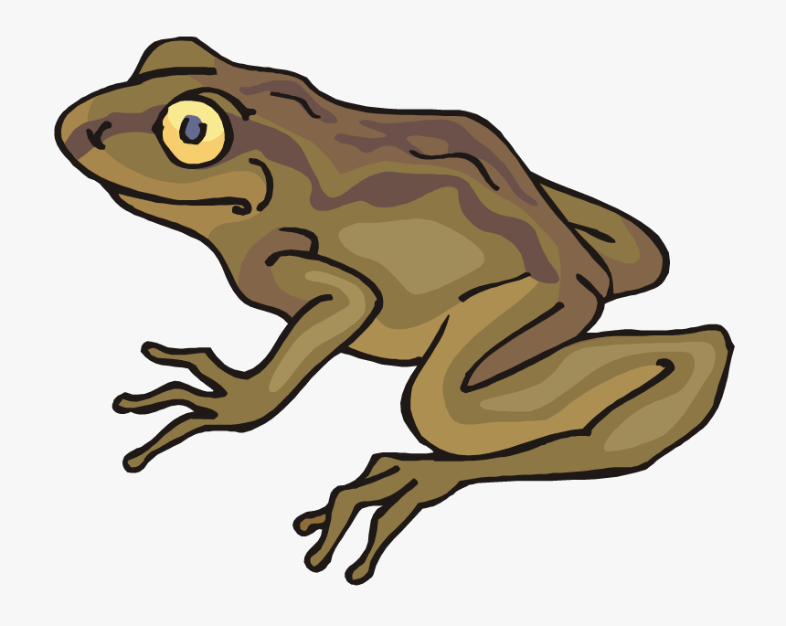 | 6.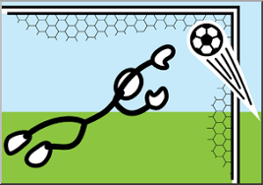

Number from 1 to 6 in your book. When you have done that, write a label for each oa word. Trace over the oa in each word in a colour.
Example:
- coat

Well done Kippers – Keep up the good work!

