www.phonicsplay.co.uk
See Y1 homepage for login details

Mon.4/ai
* We are learning a new phoneme ai and how to read and write it.*

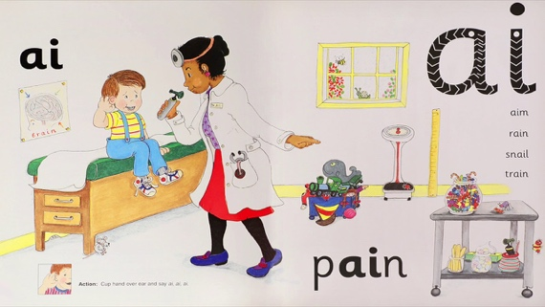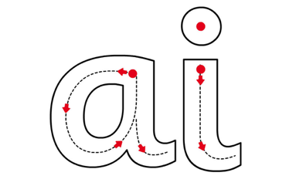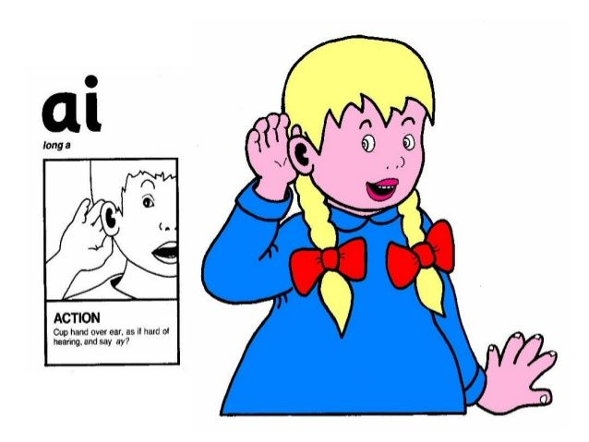

Warm-up –
Start by logging onto Phonics Play.
Flashcards (Speed Trials) - It’s time to practise our phonemes so far!
https://www.phonicsplay.co.uk/resources/phase/2/flashcards-speed-trials
*Grown-up – please choose then Sets 6, 7 and 8. Thanks!*
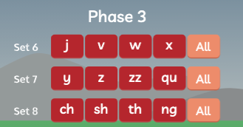
How did you get on?

New Phoneme: ai (2 letters, so it’s a digraph)
Please watch the Little Learners ai lesson. Practise your blending to help you read the words.
https://www.youtube.com/watch?v=JDzpV3jFefs

Task 1 – Can you read these words?

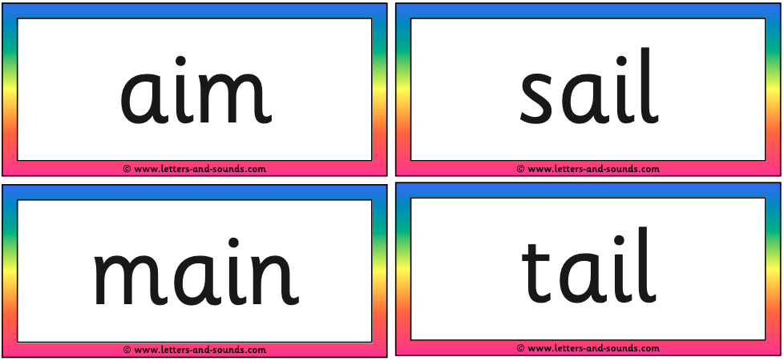

Challenge – Ask an adult to choose 3 of the ai words for you wo write. Now write the 3 words in your book.
Don’t forget to use sound buttons to help you e.g.

Task 2 – Read the ai words below:

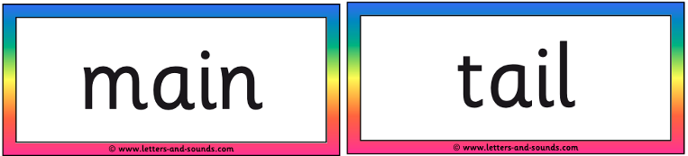

Now read the 3 sentences below. Can you choose one of the words above to fill each gap?

- I will ________ for a taxi .
- The cat has a long ________ .
- I sang a song in the ________ .

Which word did you not use? _____________

Copy the 3 finished sentences carefully into your book.

Well done Kippers –
Keep up the good work!

