www.phonicsplay.co.uk
See Y1 homepage for login details

Thurs.4/igh
* We are learning a new phoneme igh and how to read and write it.*
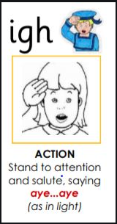

Warm-up:
Start by logging onto Phonics Play.
Play Grab a Giggling Phoneme (Phase 3). 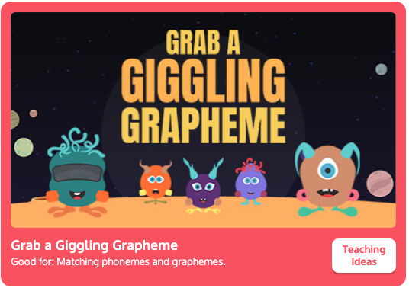
https://www.phonicsplay.co.uk/resources/phase/3/grab-a-giggling-grapheme
Click Start and then . Did you get them all?

New Phoneme: igh (3 letters, so it’s a trigraph)
Please watch the Little Learners igh lesson. Practise your blending to help you read the words.
https://www.youtube.com/watch?v=3UVtOaeBIDg

One way of remembering it is to say:

I go home … Look at the first letter of each word –
can you see igh?

Task 1 – Can you read these igh words?
*Grown-ups – Please can you cover the pictures then reveal the words as each one is read? *

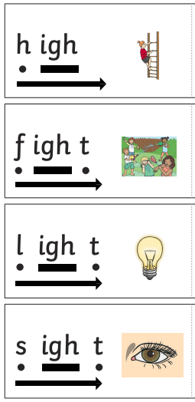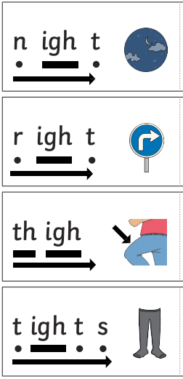

Task 2 – Now you are going to be a detective! Look closely at the woodland picture (see link attached on website). How many igh words can you find? Zoom in or use a magnifier to help! Make a list in your book of the igh words you find.
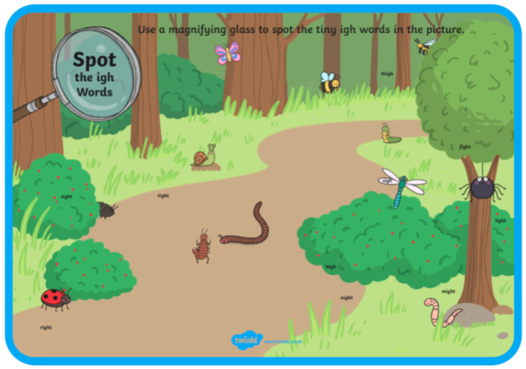
Well done Kippers – Super igh work!

