www.phonicsplay.co.uk
See Y1 homepage for login details

Thurs.4/aw

* We are learning the new grapheme aw and how to read & write it.*
Yesterday we looked at the au grapheme … today we are looking at aw – the same sound, but spelt differently.

Now watch Letters and Sounds lesson: aw
**Feel free to pause / skip ahead to suit your child’s needs.**

https://www.youtube.com/watch?v=KvRTZKWe30M&feature=youtu.be
- You will need a pencil and your book
- Draw sound buttons (e.g. ) under any ew words you are asked to write down

Task – Sound out carefully to read the words in this aw PowerPoint. (see link – today’s phonics – on website).
To play the PowerPoint, click Slide Show then Play from Start:
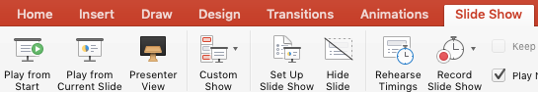
Ask an adult to read the following sentence aloud. You copy them down. Can you find and underline the aw words? How many did you find? (x4)
I saw 4 paws and some claws on the lawn.

Well done Biffs – keep it up!

