www.phonicsplay.co.uk
See Y1 homepage for login details

Tues.4/ee
* We are learning a new phoneme ee and how to read and write it.*

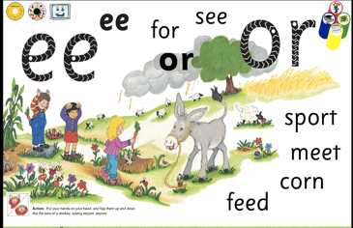

Warm-up –
Start by logging onto Phonics Play.
Let’s revise yesterday’s phoneme - ai
https://www.phonicsplay.co.uk/resources/phase/3/dragons-den
Grown-up – please choose then
How many words did you sort and read?

New Phoneme: ee (2 letters, so it’s a digraph)
Please watch the Little Learners ee lesson. Practise your blending to help you read the words.
https://www.youtube.com/watch?v=du3incCU6Xc

Task 1 – Take your time reading the ee words below. Point at the sound buttons as you read.

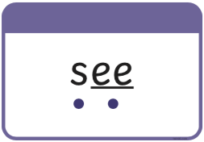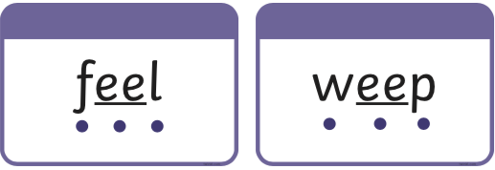

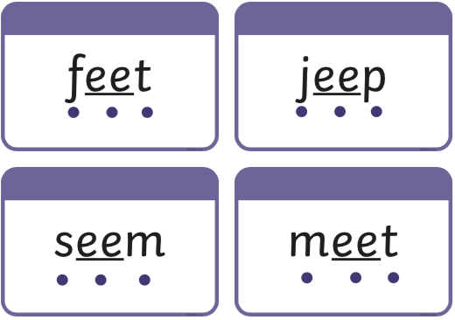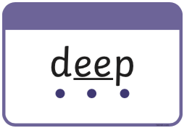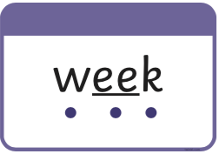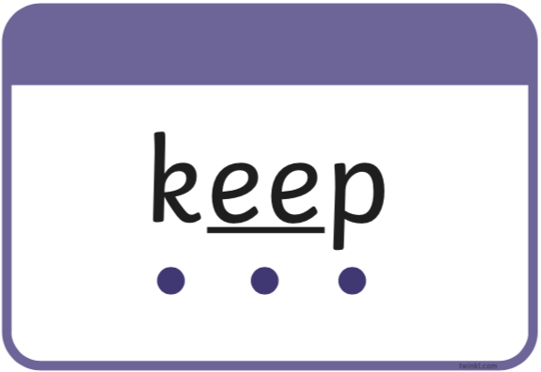

Now read them all again. Please time yourself. How long does it take you? Can you read them all in less than a minute?

Now write this sentence carefully in your book. No peeking - ask an adult to read it aloud for you!

I can see a man with big feet.
Task 2 – Log in to Espresso (Discovery Education) *See Miss Healey’s letter for logins 5.1.21.*
Now play this game
https://central.espresso.co.uk/espresso/primary_uk/subject/module/activity/item802892/gradef/module62767/index.html
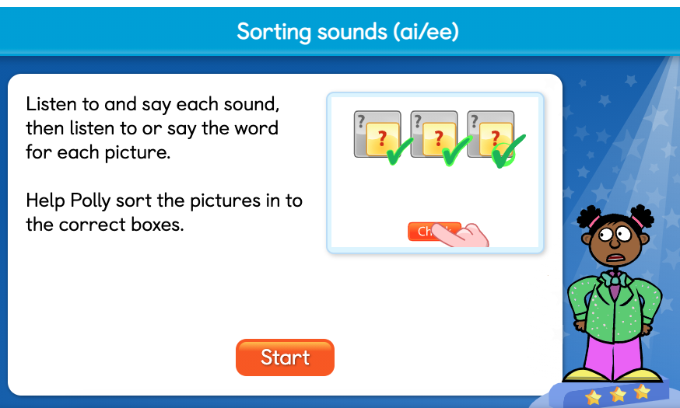
Your task is to help Polly by sorting the ee / ai words into the right groups. Good Luck!

Well done Kippers –
Keep up the good work!

