www.phonicsplay.co.uk
See Y1 homepage for login details

Weds.4 – Alphabet / key words

The Alphabet

Warm-up –
Let’s practise the alphabet song again. Sing the song, pointing to each letter as you sing.

https://www.youtube.com/watch?v=ycnPbp_CrVg

Can you remember how many letters there are altogether? Count them. You should have 26!

Tasks:

* Read through the alphabet mat from Aa to Zz. See link for today on website. Remember to use the letter names, not the sounds they make e.g. ‘ay’, ‘bee’, ‘see’ not ‘a’, ‘b’, ‘c’.
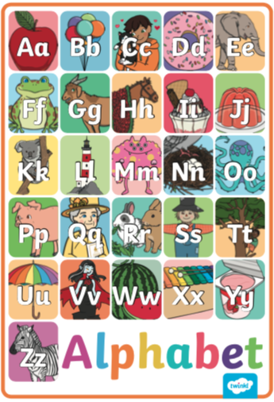

* Now play the alphabet game –Open the PowerPoint (see link on website for today), then choose Slide Show and Play from Start. Now follow the instructions!
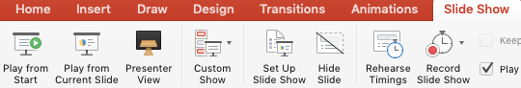
Key Words
* We are learning how to read and write these new key words:
was my

* Now have a go at these activities. Do you have play doh and/or magnetic letters? Use them if you do!
If you don’t have a printer, you can write the words / sentences in your book.

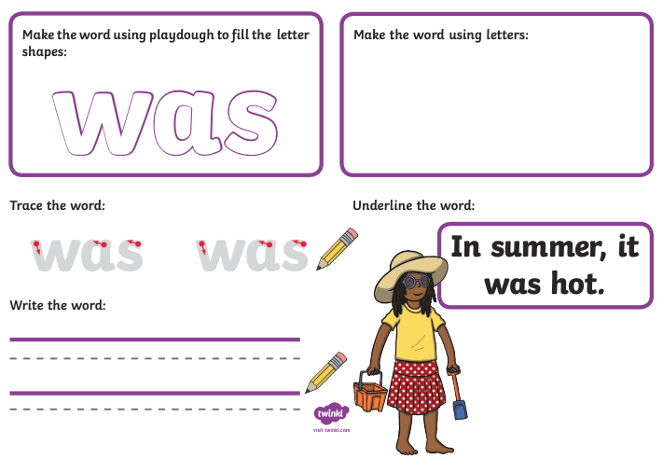
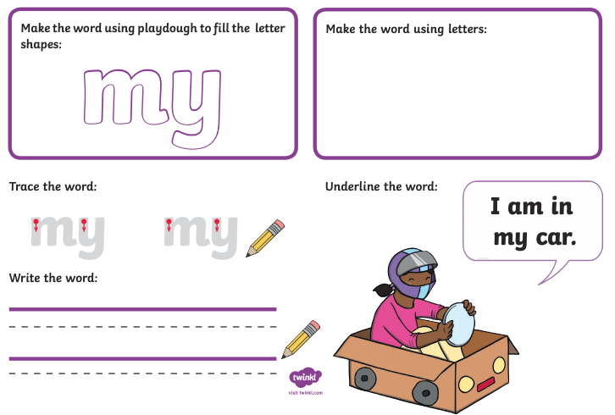

Great job Kippers!

