www.phonicsplay.co.uk
See Y1 homepage for login details
Weds.4/au

Warm-up (revision) – Play the Popping Balloons PowerPoint (see link – today’s phonics – on website). As you say the correct phoneme, pop the balloon to make it disappear.
To play the PowerPoint, click Slide Show then Play from Start:
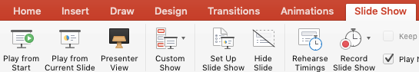

* We are learning a new grapheme au and how to read and write it.*

With your finger, write au in the air, on your hand, in sand/glitter etc.
au is a digraph (2 letters) – it is found at the start or in the middle of words.
Can you think of any words that contain ‘au’ ?

Task 1 – Can you read each of the au words? Do you know what all of the words mean? Find out the meaning of any unknown au words.
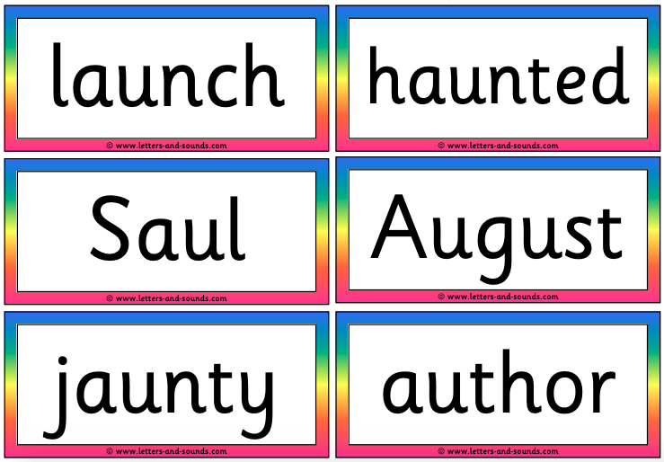
Challenge word: 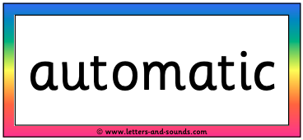
Task 2 – Log onto Phonics Play, play Buried Treasure
https://www.phonicsplay.co.uk/resources/phase/5/dragons-den
Choose (Phase 5). Read and sort the words. Take your time. Sound out carefully! How did you get on?

Task 3 – Ask an adult to read the following sentence for you:
I am going on holiday in August, said Saul the author.
Carefully write the sentence in your book. Underline the au words with a ruler. How many did you find? (x3)

Well done Biffs – Great job today!

