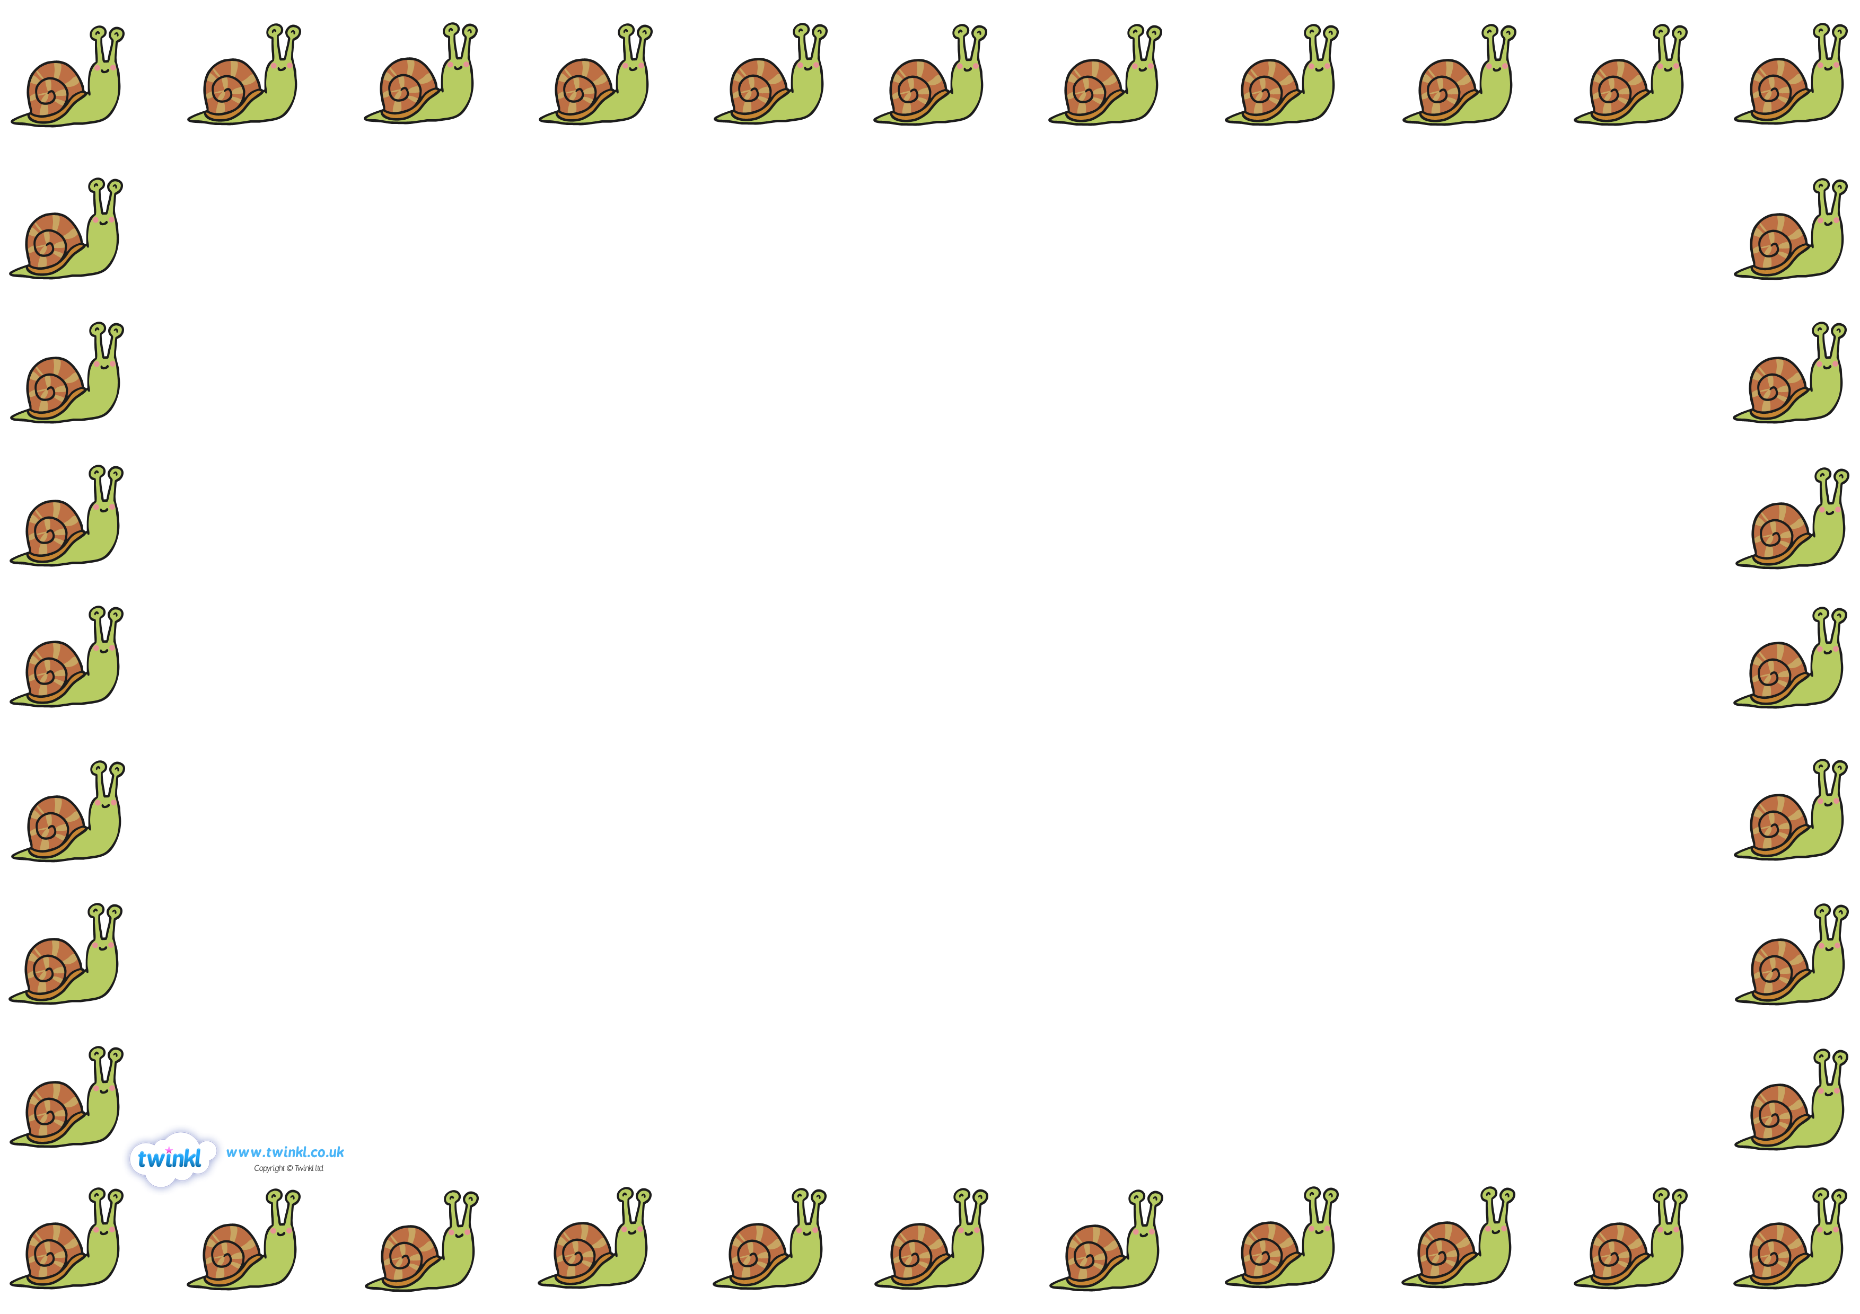

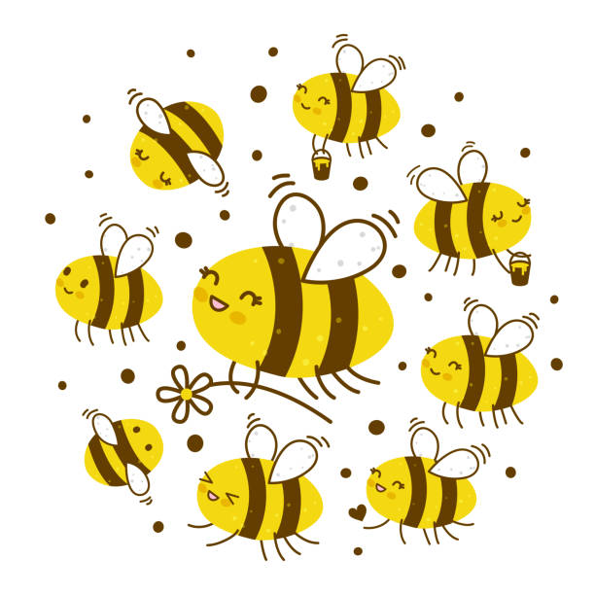

buzzing bees

**Cedric’s Day –** What has he been up to today?

*Draw pictures and add labels (see example below).*