WILF: dragon story 19/1/21  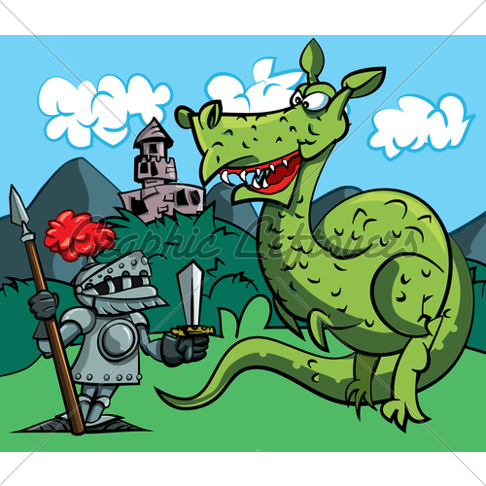 | What do I think? | What does my grown up think?
Have I used capital letters and full stops?

Have I used expanded noun phrases with commas?

Have I used at least two similes? (Use some from last week)

Have I used time sentence openers? (See separate list.)

