NEW READING SCHEME!
27.1.21
Buckstones have signed up to an American online reading scheme, which is currently available during this difficult time.
The log in details will be sent out by ParentMail.
*However it’s important to be aware of the time you log in; please see below*.
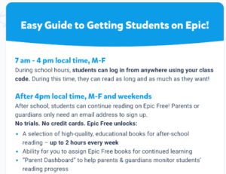
- Signing in with a parent’s email is easy and just requires you to verify the free account by clicking on an email and creating your own password.
- Once you have selected your own name you can select a book of your choice. There is a wide variety of texts including fiction, non-fiction, comics, a ‘read to me’ section where the words are highlighted as the narrator reads the story, videos and audiobooks.
- You can amend the reading level by pressing on the button that looks like a bar chart and AR next to it.
- Your teacher will be able to see your reading progression and we look forward to seeing you enjoy this scheme … HAPPY READING!!!

