Home Learning: Monday 11th January
Phonics/Handwriting: Start by looking at a new sound: th This is a tricky phoneme because it makes two different sounds! It makes the soft 'th' sound as in 'thumb' but it also makes the hard sound 'th' as in 'the'. Because it is a tricky sound we are going to spend two days learning it carefully.
Start by learning the 'th' song, then go to 'Scrap's Phonics' on Espresso . Click on the th sound and watch the video together. Next watch this 'th' sound video and then finally, can you make a large th shape using objects from around your house? Be as creative as you like - you could use play-doh, Lego bricks, paint, string - anything you like... just don't forget to take a photograph!
Here are some that I did, just to give you some ideas: 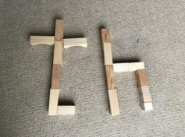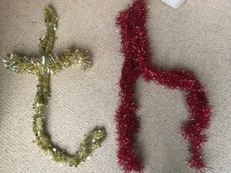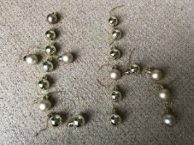

Maths: Start by singing our new numbers to 20 song. We've focussed on 11 and 12 already so today we are going to look at the next number: 13. Watch the Number 13 Numberblocks episode and then see if you can carefully count out 13 objects from around your house - it could be 13 pencils, 13 sticks, 13 teddies - anything! Just remember to count very carefully and stop when you get to 13. Finally have a go at the Number 13 worksheet (if you don't have access to a printer don't worry - just use this worksheet to look at and then practise the same skills in your workbook).

Topic: 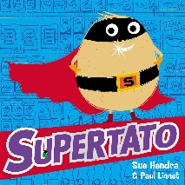Our book for this week is Supertato by Sue Hendra and Paul Linnet. If you have this book at home feel free to read your copy, otherwise I have found a great version of Supertato for you to listen to, just click on the link. Once you've heard the story discuss together - did you like the story? Why? Your challenge this afternoon is to make your very own Supertato! 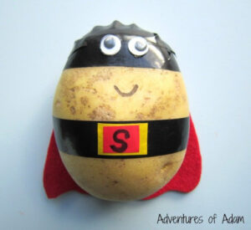
This is an open-ended task, you can be as creative as you like - you could make a junk model, you could paint a picture, you could even decorate an actual potato... I can't wait to see what you do!
* If you're stuck for ideas, use this Supertato worksheet!

Home Learning: Tuesday 12th January
Phonics/Handwriting: Start by singing all of the sounds we've learnt so far by clicking on the Jolly Phonics link; all of the songs up to and including th... don't forget to do the actions too! Watch the Alphablocks 'th' episode and think of some 'th' words together.
Finally, practise writing the 'th' sound neatly in your workbooks (please get a grown up to draw a few lines for you with a ruler first to make it a little easier) - if you want a challenge you try writing some of the 'th' words that you thought of earlier.

Maths: Start by singing our new numbers to 20 song. Then watch the Number 14 Numberblocks episode. Can you do 14 claps? Can you do 14 jumps? What other movements can you do 14 of? Remember to count carefully and stop when you get to 14!
Afterwards we're going to practise numbers to 20 by playing the number line game on espresso, working out what the missing numbers are by counting very carefully.

Topic: Read or watch Supertato by Sue Hendra and Paul Linnet again. Discuss how a lot of Superheroes wear masks over their eyes. This afternoon we're going to make our very own superhero masks - in whatever colours and designs you like! You can use this Superhero Masks sheet (card would be better than paper if possible) or just create your own... maybe you could even wear it to our Reception class zoom this afternoon so that we can all see it?!
*** Reception class Zoom 'drop in' session 2.30pm ***
Details will be sent to you via Tapestry.

Home Learning: Wednesday 13th January
Phonics/Handwriting: First learn our new sound by watching the ng video. 'ng' is another tricky sound, so we will look at it over two days. Next go to to ‘Scrap’s Phonics’ on Espresso and click on the ng button. Can you think of lots of 'ng' words? * Top tip: it's usually at the end of words, such as string, song, wedding.
Practise writing the 'ng' phoneme in your workbooks (or on paper). Many children find the 'g' particularly hard - please just remind them that their pencil must not come off the page - it is not a circle and then a separate tail, it is one continuous movement!
For an extra challenge, try writing some of the 'ng' words too!

Maths: Start by singing a numbers to 20 song. Then watch the Number 15 Numberblocks episode. Can you count out 15 objects very carefully? - What will you count out today? Afterwards we're going to play the Teddy Numbers game on Topmarks Maths: Remember to select Numbers up to 15.

Topic: First read or watch Supertato by Sue Hendra and Paul Linnet. Today we are going to think about the Evil Pea... discuss what kind of character he is!
Talk about what a 'Wanted' poster is - and how police might use them to catch baddies... 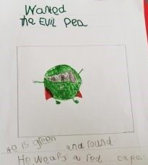Today we are going to make our own 'Wanted' posters to try and catch the Evil Pea! You can use the Wanted Poster template or just do it straight onto paper - it really doesn't matter. What we're looking for is a careful picture of the Evil Pea and a short sentence to describe what he looks like or what crimes he has committed (just one sentence is enough)! Here is an example to give you an idea:

Home Learning: Thursday 14th January
Phonics/Handwriting: Start by singing all of the sounds we've learnt so far by clicking on the Jolly Phonics link; all of the songs up to and including ng... don't forget to do the actions too! Then we're going to play a sound sorting game on Espresso. This game practises the four last sounds that we've learnt: ch, sh, th and ng.

Maths: Start by singing a numbers to 20 song. Then watch the Number 16 Numberblocks episode. Today we are going to think about writing and making number 16 (lots of children find the 6 tricky, or try to do it as two separate movements, i.e. the 'stick' and then the 'ball' rather than one continuous line)! Complete the Number 16 worksheet (or if you don't have access to a printer just use this sheet to look at and do similar activities straight into your workbook).

Topic: This afternoon we're going to think about the weather. First watch the different weather videos on espresso and discuss which type of weather you like best and why. There are two games to choose from too: 'Dressing Ash' or 'Weather Snap' (you may need to enable Flash on your computer to play these games). Then your activity is to draw and label a big picture of your favourite type of weather in your book. Make sure you hold your pencil correctly and use your very neatest colouring skills!

Home Learning: Friday 15th January
Key skills: Friday is going to be our weekly chance to focus on our key words and name writing skills.
Start by watching the tricky words song video. Then practise reading your own set of key words. *
*Every child is on a different set of key words. If your child has already passed set 8 then they will be now working on their spellings too! *
Please let us know how your child is doing with their key words (and spellings if they are at this level) - remember that to move onto the next set of words the child must be able to read their current words confidently and instantly (not by trying to sound them out or guess them)! If they are ready for their next set let me know and I will send them to you via Tapestry.
Finally, use this session to practise writing your (first) name, making sure that every letter is formed correctly and that it always starts with a capital letter!

Maths: Start by singing our numbers to 20 song. Then watch the Number 17 Numberblocks episode. Afterwards practise numbers to 20 by playing the Helicopter Rescue game on Topmarks: Click on 'Play game' then 'Find a number', 'Direct' and 1-20 (if you need more of a challenge try the 'In Between' option instead).
*** Reception class Zoom 'drop in' session 11.am ***
Details will be sent to you via Tapestry.

Forest Fun: In a few weeks time we are going to take part in the RSPB 'Big Schools Birdwatch' as part of our forest fun session. I just thought I'd mention it to you now so that you have plenty of time to get involved too if you want to (click on the link 'Big Garden Birdwatch' if you would like more information or would like to enter to do it with your family).
Today we're going to use our forest fun session to go out and spot what wildlife we can spot outdoors at this time of year. Take photographs or make a list of any animals, birds or insects that you see in your forest fun session - you could even take a pair of binoculars or a magnifying glass to help you search... please let us know what you see! We might not see many animals at this time of year of course, why do you think this is? Also use this time to look for and discuss signs of Winter again.❄❄❄

End of 'Superhero week' activity: Try the special Spiderman Cosmic Yoga exercise to finish off your superhero week!

Have a happy and safe weekend everyone 🌈

