Home Learning: Monday 18th January
Phonics/Handwriting: Start by reviewing our four newest sounds: ch, sh, th and ng. Click on each sound to play that particular song - make sure you do the actions too. 'th' is often the one that children find trickiest as they confuse it with f and v. If this is the case with you, remember the secret of pronouncing 'th' correctly is to stick your tongue out a little bit - just like the rude clowns!
Write these four sounds on pieces of paper and use them like flashcards to hold up and see if your child can read them confidently - keep going over them, try going faster and rearranging the order etc. - so that they become super confident!
Finally, can you make your favourite one of these sounds, using objects from around your house? Here are some photographs of the 'th' sound that some of our children made last week to give you some new ideas. For an extra challenge you could try making all four of the sounds... whichever you make remember to send us a photograph so that we can see!
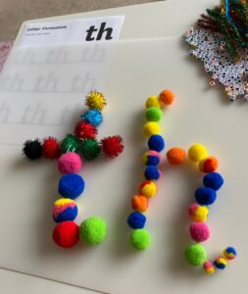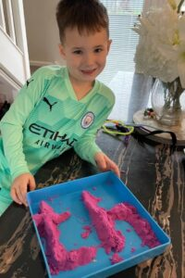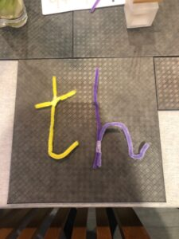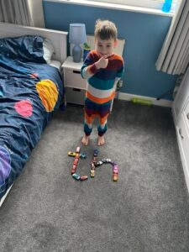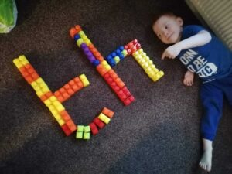

Maths: Start by singing one of our numbers to 20 songs. We've focussed on numbers up to 17 already so today we are going to look at the next number: 18. What does 18 look like? - "it's a 1 and an 8, because it's 1 ten and 8 ones".
Watch the Number 18 Numberblocks episode and then see if you can carefully count out 18 objects or actions - anything! Just remember to count very carefully and stop when you get to 18! Finally have a go at the Number 18 worksheet (if you don't have access to a printer don't worry - just use this worksheet to look at and then practise the same skills in your workbook). The 8 is a particularly tricky number for children to learn - if your child is struggling (or tries to do it as two separate circles on top of each other) then please remind them to do it as an 's' first and then join back up to the top!

Topic: For the next few weeks we are going to be learning about real-life superheroes! We'll start the afternoon by watching and singing along to the People Who help us song on Espresso. This week we are going to start with what we believe is the most important of all real-life superheroes (especially at the moment)... doctors and nurses!
First, discuss what do you already know about doctors and nurses and other health workers? Watch this Espresso video called Who can help when you are ill? then we're going to make/decorate our own posters to say a huge thank you to the NHS for being superheroes! To do this you can choose from one of these poster templates: NHS Heroes! NHS Thank You NHS Rainbow or you can make your own, using paint, collage materials or anything you like... we can't wait to see your fabulous posters!
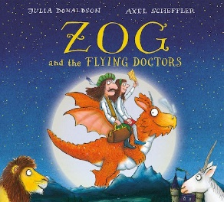Finish your 'school day' with our story of the week: Zog and the Flying Doctors by Julia Donaldson and Axel Scheffler. If you have this book at home feel free to read your copy, otherwise I have found a version of Zog and the Flying Doctors for you to listen to here, just click on the link (I am aware that there is an official animated version on BBCiplayer - we are saving this until the end of the week!😊) .

Home Learning: Tuesday 19th January
Phonics/Handwriting: Start by singing our four newest sounds again: ch, sh, th and ng. Then go to Scrap's Phonics on Espresso. Start at the top of the path and read each sound carefully as you work your way down. If you know the sound confidently move onto the next sound, but if you are not sure - or get it muddled with another sound, then click on that particular sound on the path so that you can watch the video and practise it a little bit more.
When you have finished you can go to the Activities section of Scrap's Phonics and choose any of the games on there to practise your phonics skills *choose whichever sounds you feel your child needs to practise the most.

Maths: Start with a numbers to 20 song and then we're going to watch the Numberblocks number 19 episode. What does 19 look like? it's a 1 and an 9, "because it's 1 ten and 9 ones". What can you count today? - 19 cars, 19 jumps, 19 funny faces... anything you like, just remember to stop at 19! Next we're going to cut and stick numbers to 20 in order using this Numbers To 20 Activity If you don't have access to a printer it really doesn't matter, just write the numbers 11-20 on a piece of paper in a jumbled up order and ask your child to cut them out and stick them in the right order - this is to give them some vital cutting practise too!

Topic: Start by reading our story of the week again: Zog and the Flying Doctors by Julia Donaldson and Axel Scheffler. Afterwards, there is a beautiful palace picture on Purple Mash, like the palace in the story, but it looks very plain and boring - it needs your computing skills to decorate it! Go to the Palace picture in the Art section of Purple Mash and decorate the palace the way that you would like it to look if it was your home - be as creative as you like! 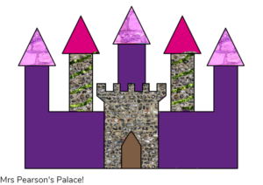
Please save it with your name in the Reception: Palace folder. Here is my palace, I can't wait to see yours!

*** Reception class Zoom 'drop in' session 2.30pm ***
Details will be sent to you via Tapestry.

Home Learning: Wednesday 20th January
Phonics/Handwriting: Start by playing the Flash cards speed sounds game on Phonics Play. To get the right sounds for us you need to select Pick individual graphemes and then click All on sets 1 to 8 (this will make sure that it uses all the sounds up to and including ng).
You can then pick the race track, colour and design for your car! The idea is to challenge yourself to see how many graphemes (written sounds) you can get right in 2 minutes. Get your adult to click on 'correct' if you say the sound correctly or 'incorrect' if you get it wrong - this is really useful because at the end it will give you a list of which sounds you need to practise. Have a look at these sounds together afterwards.
Try playing again and seeing if you can beat your first score!

Maths: Start with a numbers to 20 song and then we’re going to watch the Numberblocks number 20 episode. What does 20 look like? it’s a 2 and a 0, “because it’s 2 tens and 0 ones“. What can you count today? – 20 building blocks, 20 claps, 20 knocks on the door… anything you like, just remember to stop at 20! Then today we're going to concentrate on writing all of the numbers - making sure that they are formed correctly. First watch the writing numbers video on Espresso and then practise writing the numbers yourself - using either this Number Formation worksheet, or just writing the numbers out neatly in your book - just remember that all numbers start at the top!

Topic: First we're going to look at this People Who Help Us Hospital Video Powerpoint (remember to click on 'slide show' and 'from beginning' to make it work properly). Then discuss - have you ever been in hospital? Were you born in hospital? If you've never been to hospital you could talk about visits to the doctors instead. Then think of one sentence of something you've discussed e.g. "I had my tonsils out in hospital", "The doctor gave me medicine to make me better" or "I like my doctor". Write the sentence and draw a picture to go with it.
To finish, there is a special version of our story of the week - read not only by the author and illustrator of the story but also lots of the health workers from Great Ormond Street Hospital too: Zog and the Flying Doctors.

Home Learning: Thursday 21st January
Phonics/Handwriting: Start by singing all of the sounds we've learnt so far by clicking on the Jolly Phonics link; all of the songs up to and including ng... don't forget to do the actions too!
Then play the Flash cards speed sounds game on Phonics Play again, to see if you can beat yesterday's score. Don't forget, to get the right sounds for us you need to select Pick individual graphemes and then click All on sets 1 to 8 (this will make sure that it uses all the sounds up to and including ng).

Maths: Start with a numbers to 20 song. Then we'll watch a new Numberblocks episode - this one goes over numbers 11-15. Next, we're going to practise becoming really confident at reading and recognising numbers to 20 by solving some number puzzles - we're going to look at lots of number lines... where some of the numbers are missing! Play the Missing numbers (0-20) game on Espresso - You've got to use your super number skills to try and work out which numbers are missing and then find that number, to go back where it should be!

Topic: Thursday afternoon is going to be our 'craft afternoon'. First watch the Keeping you healthy video on Espresso and discuss what you have seen/learnt from the video afterwards. This week your challenge is to make something to do with our wonderful health workers and NHS. It could be a model/picture of a doctor or nurse, it could be your own medical bag or hat, it could even be an ambulance! This is an open-ended task, you can be creative as you like and use whatever resources you have around your house... it would be wonderful if you could bring whatever you make to our Zoom session tomorrow so that we can all see what you make!
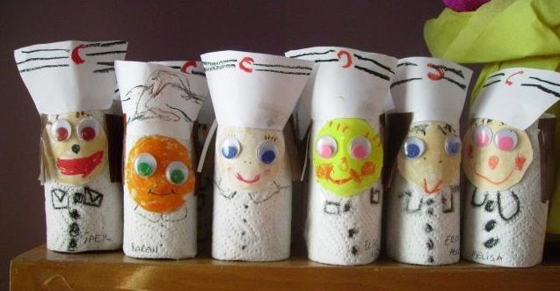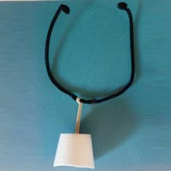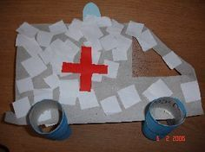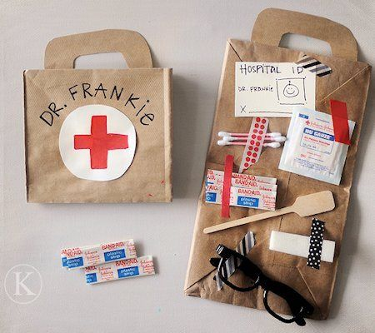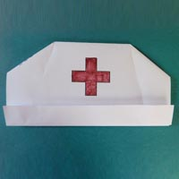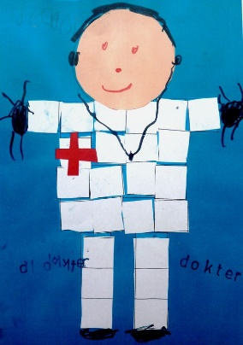

Home Learning: Friday 22nd January
Key skills: Friday is our weekly chance to focus on our key words and name writing skills.
Start by watching the tricky words song video again. Then practise reading your own set of key words. *
*Every child is on a different set of key words. If your child has already passed set 8 then they will be now working on their spellings too! *
Please let us know how your child is doing with their key words (and spellings if they are at this level) - remember that to move onto the next set of words the child must be able to read their current words confidently and instantly (not by trying to sound them out or guess them)! If they are ready for their next set let me know and I will send them to you via Tapestry.
Finally, use this session to practise writing your (first) name, making sure that every letter is formed correctly and that it always starts with a capital letter!

Maths: Start by singing one of our numbers to 20 songs then we'll watch a new episode of Numberblocks which focuses on numbers 16-20. Next we're going to think back to yesterday's session where we were finding missing number lines on a number line. We're going to build on this skill today by writing the missing numbers carefully (remembering the correct number formation). To do this you can either use this Superhero Missing Number 1 to 20 sheet or just write your own 1-20 number lines (with some numbers missing!) and get your child to try and fill in the missing numbers.
*** Reception class Zoom 'drop in' session 11.am ***
Details will be sent to you via Tapestry.

Forest Fun: This week we are going to introduce what birdwatching is by watching the Birdwatch video on Espresso – and explain that next week we will do a proper birdwatch, using a special tick sheet like on the video. (click on the link 'Big Garden Birdwatch'if you would like more information or would like to enter to do it with your family at home).
Then we are going to have a go at making our own bird-feeders. There are plenty of ideas on the internet but here some ideas to get you started, including some beautiful ones made by our very own Emily!
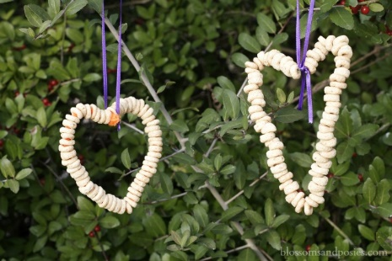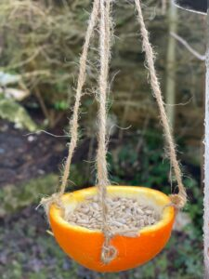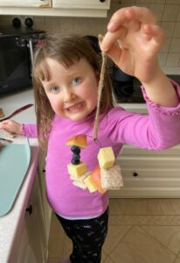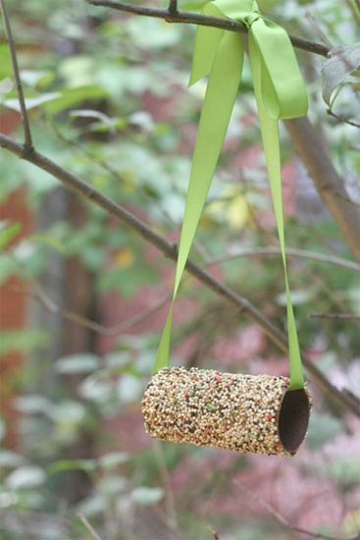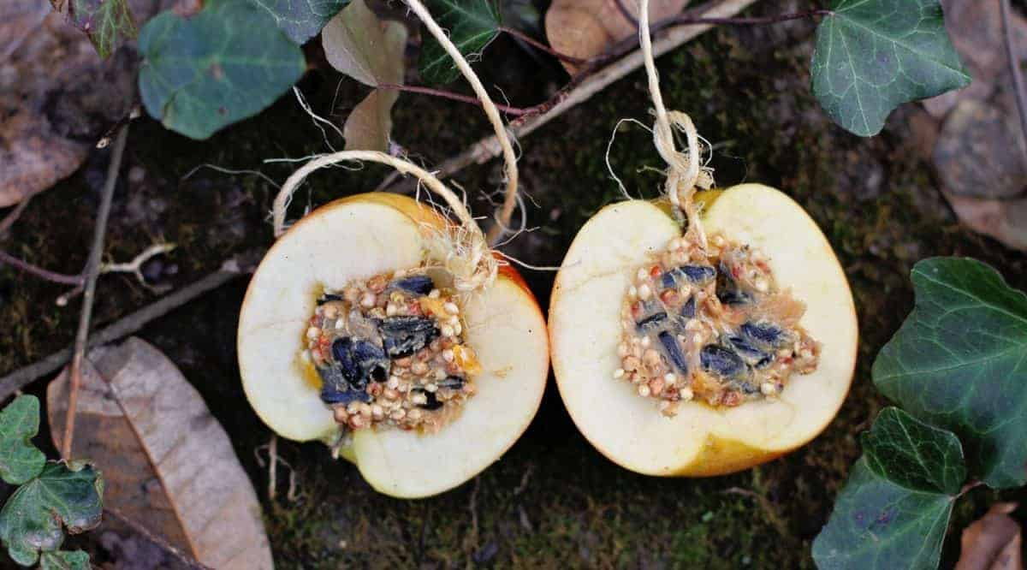
You could use nuts, seeds, bread, fruit, cheese, raisins, - whatever you have spare!
Here are some instructions that might be useful:
Cheerios Bird Feeder Instructions
Making Bird Feeder Instructions
Peanut Butter Bird Feeder Instructions
Yoghurt Pot Bird Feeder Instructions
Once you've made your birdfeeder, you need to decide where you're going to put it - and take a photograph for us when it's in place!

End of 'Health Workers week' activity: To finish our week on health workers we are going to watch the short animated film of our story of the week: Zog and the Flying Doctors... sit back and enjoy!

Have a happy and safe weekend everyone 🌈
p.s. Happy Birthday to Beatrice LB for Saturday! 🎉🎁🎂

