Home Learning: Monday 25th January
Phonics/Handwriting: This week we are going to make sure we are super confident with all of the sounds on Scrap's Phonics. We're also going to work on our letter formation every Monday - just to make sure that all letters are being formed correctly!
Start by singing all of the sounds we've learnt so far by clicking on the Jolly Phonics link; all of the songs up to and including ng... don't forget to do the actions too! Afterwards we're going to practise writing a set of letters that are in the same 'family' because they all start the same way: The 'Ladder Letters' are l,i,t,u,j,y - they all start at the top and go straight down (like a ladder). You can either use the Ladder Letters sheet or just practise these letters in your books - making sure that they are all formed correctly (the 'y' is the one which children tend to find tricky)!

Maths: Start with this Counting to 20 song. Then this week we are going to focus on addition. Watch my introduction to addition video and then please just reinforce that addition means putting things together and the sign we use for add is + .
To practise adding two numbers together we are going to play the Addition to 10 game on Topmarks Maths.

Topic: This week we're going to look at really important 'real-life' superheroes... the police! Start by watching the Police Officers Espresso video and then discuss what you already know about police officers. Then we're going to get 'arty' and draw, paint or colour a picture of a police officer or some special police equipment. Here are some Police Colouring Pages if you want to colour. Don't forget to take a photograph so we can see what you do!

Home Learning: Tuesday 26th January
Phonics/Handwriting: To start, play the Flash cards speed sounds game on Phonics Play again, to see if you can beat last week's score. Don't forget, to get the right sounds for us you need to select Pick individual graphemes and then click All on sets 1 to 8 (this will make sure that it uses all the sounds up to and including ng). Afterwards practise any sounds that you found tricky.
Then go to the Activities section of Scrap's Phonics and choose any of the games on there to practise your phonics skills *choose whichever sounds you feel your child needs to practise the most.

Maths: Start with a new counting to 20 song. Then we're going to think about addition again. Remember when you add two things together the answer will always be bigger! Watch my adding video again to remind yourself of how I added, using objects from around the classroom. Then it's your turn! Can you use objects from around your house to answer these addition number sentences? (write the completed number sentences down in your books):
- 2 + 3 =
- 5 + 1 =
- 4 + 2 =
- 3 + 4 =
- 6 + 3 =
- For an extra challenge can you make 3 more addition number sentences of your own?

Topic: Start by going through the police information book and watch the Police dogs video (both on Espresso). Discuss what you have found out, or what you found most interesting. Finally, for our computing task this week we are going to play the 'Police snap' game (you can adjust the speed of the game if your child is finding it too easy or too hard).
***Reception class Zoom 'drop in' session 2.30pm ***
Details will be sent to you via Tapestry.

Home Learning: Wednesday 27th January
Phonics/Handwriting: To start, go to Scrap's Phonics on Espresso. Start at the top of the path and read each sound carefully as you work your way down. If you know the sound confidently move onto the next sound, but if you are not sure - or get it muddled with another sound, then click on that particular sound on the path so that you can watch the video and practise it a little bit more.
Afterwards press on the 'Tricky Words' sign at the end of the path and watch that video together. Then play the Reading tricky-high frequency words game on Espresso.

Maths: Start by joining in with this counting to 20 video. Then we're going to practise our addition skills again. We'll start by watching a new Numberblocks episode which looks at addition. Then we're going to solve more addition problems. You can either use this Superhero Addition To 10 sheet, or if you don't have access to a printer just draw simple dots for your child to add together, up to a total of 10 (just make sure the dots are large enough to count easily). As long as they are practising their addition skills it doesn't matter what it is that they're counting!

Topic: Does anyone remember (from Monday's video) how to contact the police in an emergency? Watch the 999 video together and then discuss how important it is to only ever ring 999 if it is a real emergency. Can you make a poster to tell people to ring 999 in an emergency? - Don't forget to take a picture for us!
Finish by watching/singing the People Who help us song again.

Home Learning: Thursday 28th January Happy Birthday to Leo! 🎉🎁🎂
Phonics/Handwriting: To start, play the Flash cards speed sounds game on Phonics Play again, to see if you can beat Tuesday's score. Don't forget, to get the right sounds for us you need to select Pick individual graphemes and then click All on sets 1 to 8 (this will make sure that it uses all the sounds up to and including ng). Afterwards practise any sounds that you found tricky.
Then the 'click on the 'tricky Words' sign at the end of Scrap's Phonics path on Espresso and watch the video again. Afterwards play the Spelling tricky high-frequency words game on Espresso.

Maths: Today we're going to have a revision of numbers to 20. First watch the counting to 20 Numberblocks episode. Then watch (and join in with) the writing numbers to 20 song on Espresso. Finally, practise writing out numbers 1-20 neatly in your books - remember that all numbers start at the top!

Topic: Thursday is our 'craft afternoon'. Start by watching a short Police story together, then we're going to think about police officers and the equipment that they might use. What could you make today?
Here is a Police Identity Badge Template you could use to create your own police badge, or here are some examples of other police craft ideas to give you some inspiration:
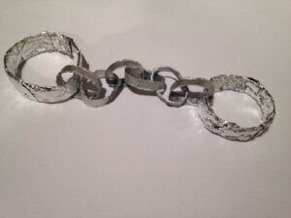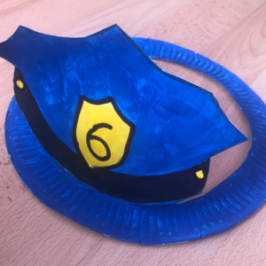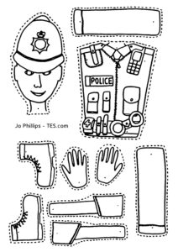
We can't wait to see what you make! Please bring your police craft to tomorrow's zoom session to show us 👍👮‍♀️👮‍♂️

Home Learning: Friday 29th January
Key skills: Friday is our weekly chance to focus on our key words and name writing skills.
Start by watching the tricky words song video again. Then practise reading your own set of key words. *
*Every child is on a different set of key words. If your child has already passed set 8 then they will be now working on their spellings too! *
Please let us know how your child is doing with their key words (and spellings if they are at this level) - remember that to move onto the next set of words the child must be able to read their current words confidently and instantly (not by trying to sound them out or guess them)! If they are ready for their next set let us know and we will send them to you via Tapestry.
Finally, use this session to practise writing your (first) name, making sure that every letter is formed correctly and that it always starts with a capital letter!

Maths: Start with one of our favourite Counting to 20 songs. Then to refresh addition skills, play the Addition to 10 game on Topmarks Maths that we played for the first time on Monday.
*** Reception class Zoom 'drop in' session 11.am ***
Details will be sent to you via Tapestry.

Forest Fun: This week we are taking part in the RSPB Big School's Birdwatch. You can either just go along with what we do in school on Friday or you can register to do the RSPB Big Garden Birdwatch at home (any time between the 29th and 31st January) - they are basically the same thing, just that one is for homes and one is for schools!
We will start by watching the Birdwatch video on Espresso. Then we'll familiarise ourselves with the different types of bird that are on our lists before going outside and carefully, quietly taking part in the actual birdwatch. I can't wait to hear which birds you see at home - I wonder if our results will all be very similar? Here is the checklist that we will be using in school: Rspb Big Schools Birdwatch Counting Sheet.

End of 'Health Workers week' activity: Sit back and enjoy the Let's Play Police Officer episode from CBeebies.

Have a happy and safe weekend everyone 🌈

