WALT; identify the human and physical features of Coll

[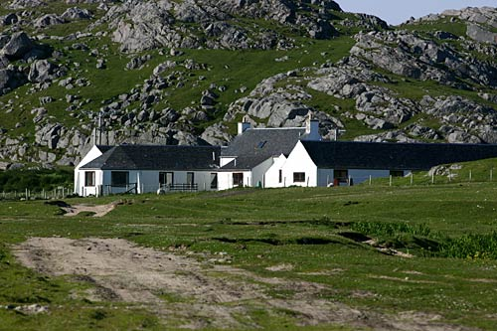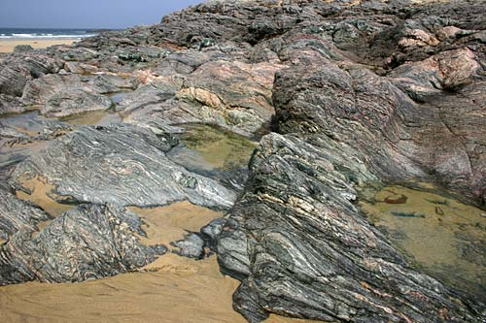](http://www.colldigital.co.uk/photo-library.php?cat1=Isle%20of%20Coll&cat2=Landscape&display=16&page=5)[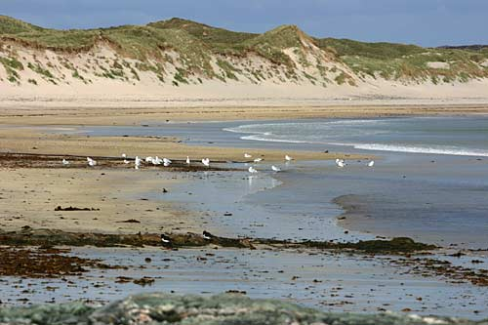](http://www.colldigital.co.uk/photo-library.php?cat1=Isle%20of%20Coll&cat2=Landscape&display=16&page=2)[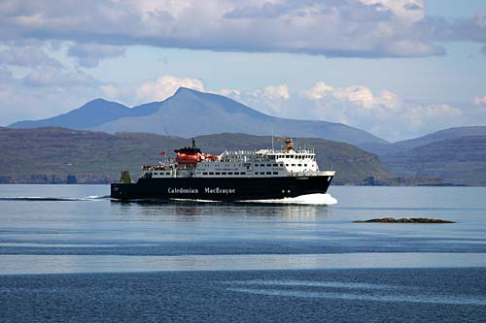](http://www.colldigital.co.uk/photo-library.php?cat1=Isle%20of%20Coll&cat2=Transport&display=16&page=1)[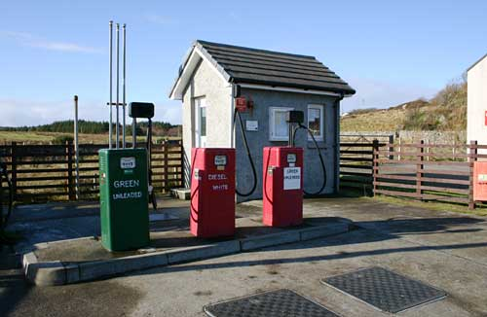](http://www.colldigital.co.uk/photo-library.php?cat1=Isle%20of%20Coll&cat2=Landscape&display=16&page=8)[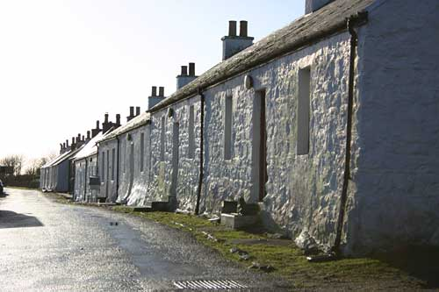](http://www.colldigital.co.uk/photo-library.php?cat1=Isle%20of%20Coll&cat2=Landscape&display=16&page=4)[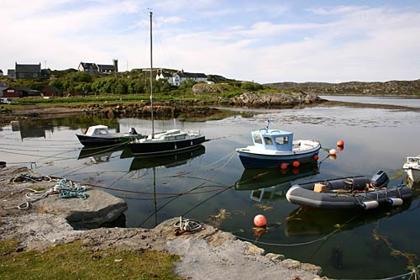](http://www.colldigital.co.uk/photo-library.php?cat1=Isle%20of%20Coll&cat2=Landscape&display=16&page=1)[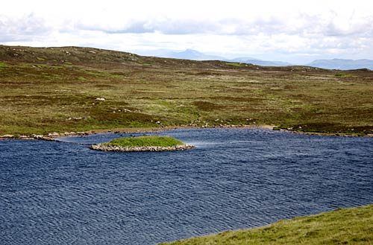](http://www.colldigital.co.uk/photo-library.php?cat1=Isle%20of%20Coll&cat2=Landscape&display=16&page=2)[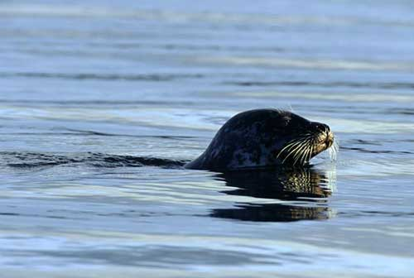](http://www.colldigital.co.uk/photo-library.php?cat1=Isle%20of%20Coll&cat2=Sea%20Life&display=16&page=1)[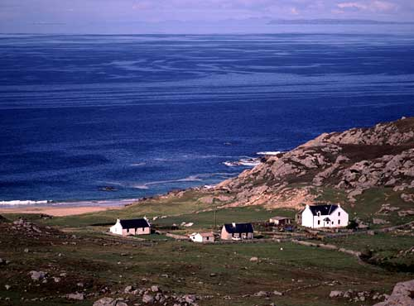](http://www.colldigital.co.uk/photo-library.php?cat1=Isle%20of%20Coll&cat2=Landscape&display=16&page=1)[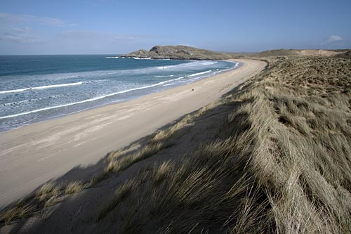](http://www.colldigital.co.uk/photo-library.php?cat1=Isle%20of%20Coll&cat2=Landscape&display=16&page=3)[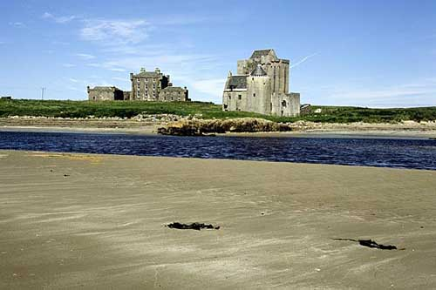](http://www.colldigital.co.uk/photo-library.php?cat1=Isle%20of%20Coll&cat2=Landscape&display=16&page=1)

visitor centre

rocks

beach

ferry

petrol station

castle

village

harbour

loch

seal

cliffs

sand dunes