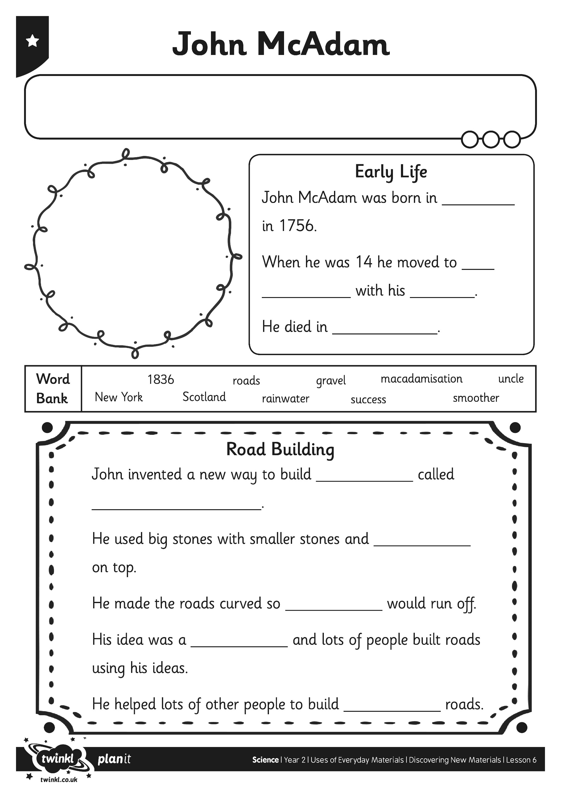
I can tell you about the inventor John McAdam
I can tell you about the inventor John McAdam
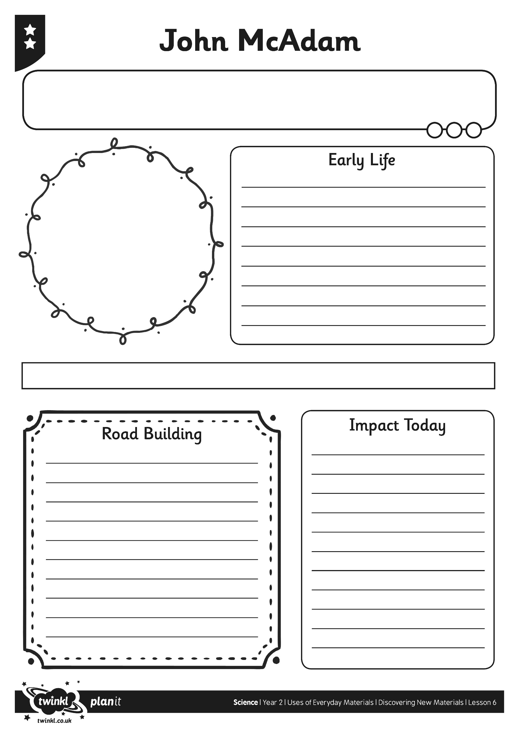

I can tell you about the inventor John McAdam
