PSHE Lesson 1 – Feeling Good
This afternoon’s lesson (Lesson 1 – Feeling Good) is all about emotions and how we feel. In this lesson, you will be talking about feelings and how people respond to them. You will meet Bobby and friends who will talk to you about how they feel and you will have the chance to talk about how you have been feeling too. https://classroom.thenational.academy/lessons/feeling-good-6hj64d
- First, follow the directions on the video then pause the lesson at 3:33 mins.

- Now ask yourself - How are you feeling today? Use this Emotions.Chart to help you. How are you feeling at the moment? Which other emotions have you felt today / this week? What about other people in your family / class? You might find that others are feeling just like you!

- In the next part of the lesson (3:35 mins), you will be asked to look at some people and decide how they are feeling. Pause the lesson and use the emotions poster to help you if you need to do. The ‘answers’ will be revealed at 4:28 mins. Did you agree? Stop the video after this.
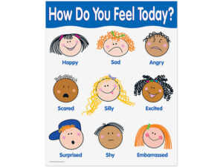
Follow-up Task:
Choose one of the following emotions that you might have been feeling recently – angry, sad, tired, scared or bored. Look at these Managing My Emotions Posters X5 … choose the poster(s) that matches that emotion – look at some of the advice that it gives. Can you add a helpful strategy of your own? Share your ideas with a friend or family member - it might help them out! Make a poster to help you the next time you feel that way. Keep it somewhere safe.
If you have a printer, you can print and colour your poster; don't worry if you don't, you could make / colour a poster of your own on a separate piece of paper. 🥰 Make your poster nice and colourful then put it somewhere safe so you can use it if you ever need to do. 🥰
To finish, we are going to sing If You're Happy and You Know It 😊👏🎶 https://www.youtube.com/watch?v=71hqRT9U0wg

