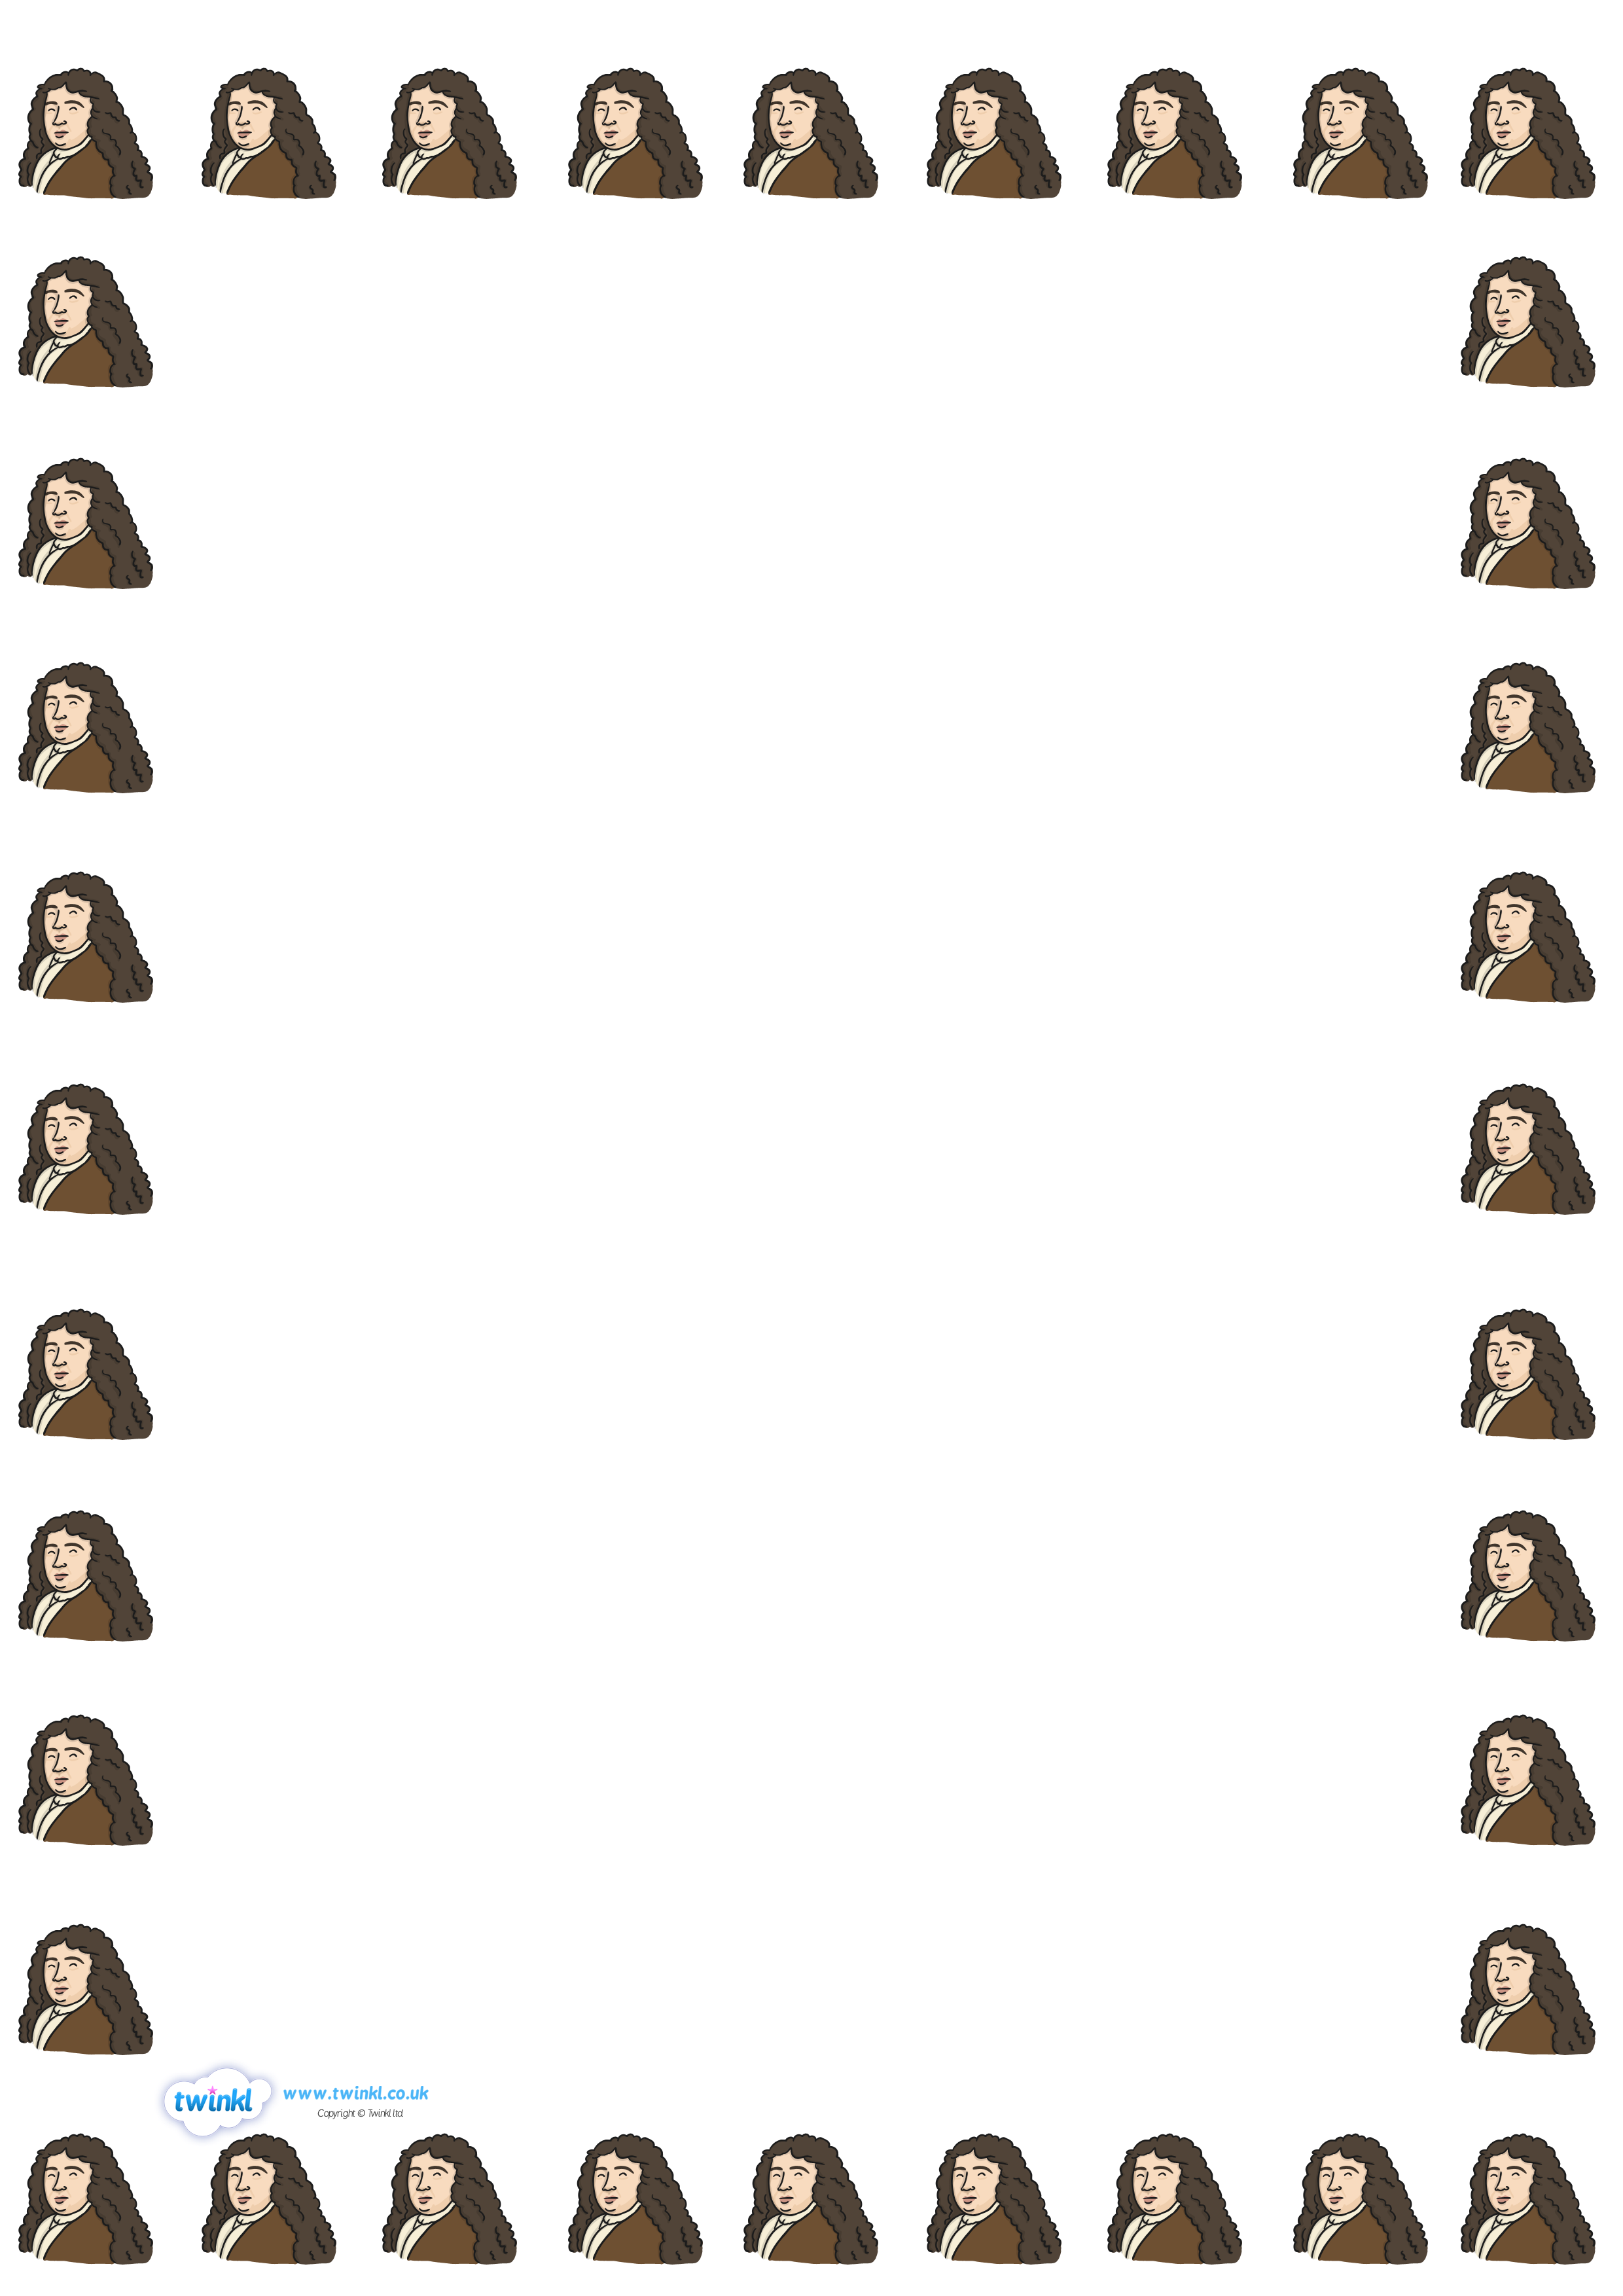

My Sketch of Samuel Pepys