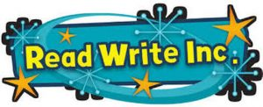

Suggested Read Write Inc. Home Reading Books

The Read Write Inc. books run alongside the regular Oxford Reading Tree books.

To find them, log into Oxford Owl as normal. The Read Write Inc. books should be on the bookshelf next to the regular eBooks:
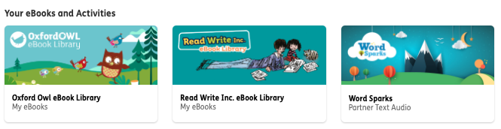

**Once you’ve clicked on the Read Write Inc. eBook Library, click on Levels to find the right books.**

Keep your eyes peeled for activities that accompany some of the books:

*It isn’t a case of each level having a number (like our regular Oxford Reading Tree books), instead each Read Write Inc. level is a colour.* Please see guide below to help you find the right books to read with your child:

If your child is on Oxford Reading Tree Level 1 / 1+ books, maybe try these:

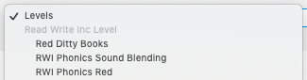

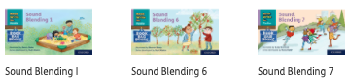

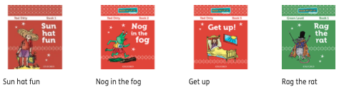

If your child is on Oxford Reading Tree Level 2 books,
maybe try these:

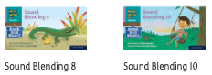
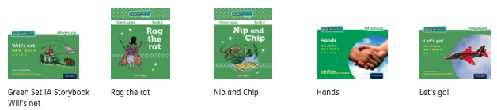
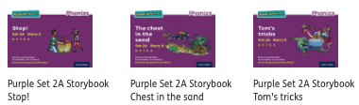

If your child is on Oxford Reading Tree Level 3 books,
maybe try these:

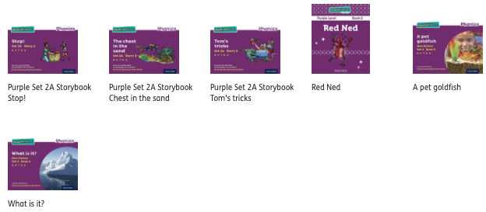
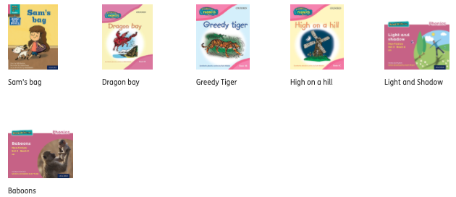

If your child has just started Oxford Reading Tree Level 4 books, maybe try these:

