WALT: plan a dragon story Date……………………………………………………………………………..

Draw your dragon here:  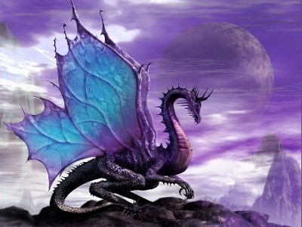 | What other characters are there? (Use expanded noun phrases)  a tired, grumpy king  a, bold, brave knight  a sweet, gentle princess | Where does the story take place? (Use expanded noun phrases)  a small, quiet village  a deep, twisting river  a cold, dark cave
The Beginning: (Draw a picture)  How and where does the story start? | The Middle: (Draw a picture)  What is the problem? What goes wrong? | The End: (Draw a picture)  How is the problem sorted out? Is it a happy ending?

