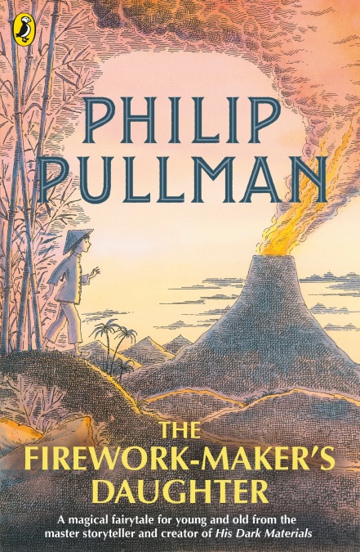

Chapter One

A thousand miles ago, in a country east of the jungle and south of the mountains, there lived a Firework-Maker called Lalchand and his daughter Lila.
Lalchand’s wife had died when Lila was young. The child was a cross little thing, always crying and refusing her food, but Lalchand built a cradle for her in the corner of the workshop, where she could see the sparks play and listen to the fizz and crackle of the gunpowder. Once she was out of her cradle, she toddled around the workshop laughing as the fire flared and the sparks danced. Many a time she burnt her little fingers, but Lalchand splashed water on them and kissed her better, and soon she was playing again.
When she was old enough to learn, her father began to teach her the art of making fireworks. She began with little Crackle-Dragons, six on a string. Then she learned how to make Leaping Monkeys, Golden Sneezes, and Java Lights. Soon she was making all the simple fireworks, and thinking about more complicated ones.
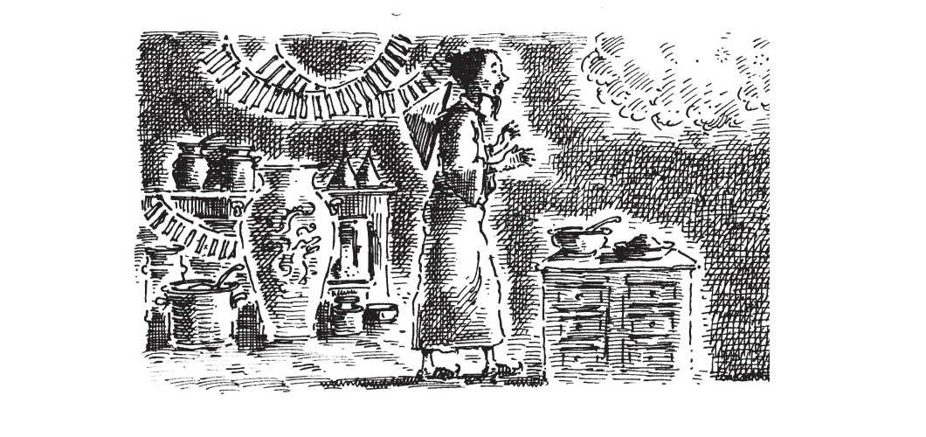
One day she said, ‘Father, if I put some flowers of salt in a Java Light instead of cloud-powder, what would happen?’
‘Try it and see,’ he said.
So she did. Instead of burning with a steady green glimmer, it sprayed out wicked little sparks, each of which turned a somersault before going out.
‘Not bad, Lila,’ said Lalchand. ‘What are you going to call it?'
‘Mmm... Tumbling Demons,’ she said.
‘Excellent! Make a dozen and we’ll put them into the New Year Festival display.’
The Tumbling Demons were a great success, and so were the Shimmering Coins that Lila invented next. As time went on she learned more and more of her father’s art, until one day she said, ‘Am I a proper Firework-Maker now?’
‘No, no,’ he said. ‘By no means. Ha! You don’t know the start of it. What are the ingredients of fly-away powder?’
‘I don’t know.’
‘And where do you find thunder-grains?’
‘I’ve never heard of thunder-grains.’
‘How much scorpion oil do you put in a Krakatoa Fountain?’
‘A teaspoonful?’
‘What? You’d blow the whole city up. You’ve got a lot to learn yet. Do you really want to be a Firework-Maker, Lila?’
‘Of course I do! It’s the only thing I want!’
‘I was afraid so,’ he said. ‘It’s my own fault. What was I thinking of? I should have sent you to my sister Jembavati to bring you up as a dancer. This is no place for a girl, now I come to think of it, and just look at you! Your hair’s a mess, your fingers are burned and stained with chemicals, your eyebrows are scorched... How am I going to find a husband for you when you look like that?’
Lila was horrified.
‘A husband?’
‘Well, of course! You don’t imagine you can stay here forever, do you?’
They looked at each other as if they were strangers. Each of them had had quite the wrong idea about things, and they were both alarmed to find it out.
So Lila said no more about being a Firework-Maker, and Lalchand said no more about husbands. But they both thought about them, all the same.
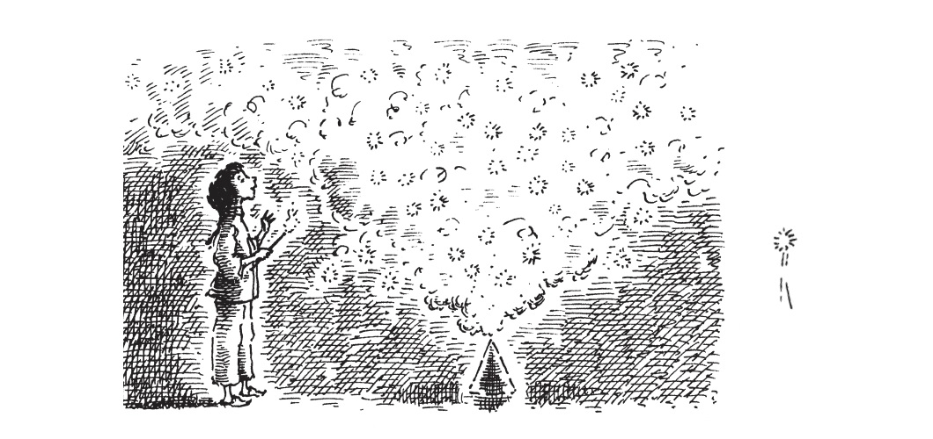
Now the King of that country owned a White Elephant. It was the custom that whenever the King wanted to punish one of his courtiers, he would send him the White Elephant as a present, and the expense of looking after the animal would ruin the poor man; because the White Elephant had to sleep between silk sheets (enormous ones), and eat mango-flavoured Turkish Delight (tons of it), and have his tusks covered in gold leaf every morning. When the courtier had no money left at all, the White Elephant would be returned to the King, ready for his next victim.
Wherever the White Elephant went, his personal servant had to go too. The servant’s name was Chulak, and he was the same age as Lila. In fact, they were friends.
Every afternoon Chulak would take the White Elephant out for his exercise, because the Elephant would go with no-one else, and there was a reason for this: Chulak was the only person, besides Lila, who knew that the Elephant could talk.
One day Lila went to visit Chulak and the White Elephant. She arrived at the Elephant House in time to hear the Elephant Master losing his temper.
‘You horrible little boy!’ he roared. ‘You’ve done it again, haven’t you?’
‘Done what?’ said Chulak innocently.
‘Look!’ said the Elephant Master, pointing with a quivering finger at the White Elephant’s snowy flanks.
Written all over his side in charcoal and paint were dozens of slogans:
EAT AT THE GOLDEN LANTERN
BANGKOK WANDERERS FOR THE CUP
STAR OF INDIA TANDOORI HOUSE
And right at the very top of the White Elephant’s back, in great big letters:
CHANG LOVES LOTUS
BLOSSOM TRUE XXX
‘Every day this Elephant comes home with graffiti all over him!’ shouted the Elephant Master.
‘Why don’t you stop people doing it?’
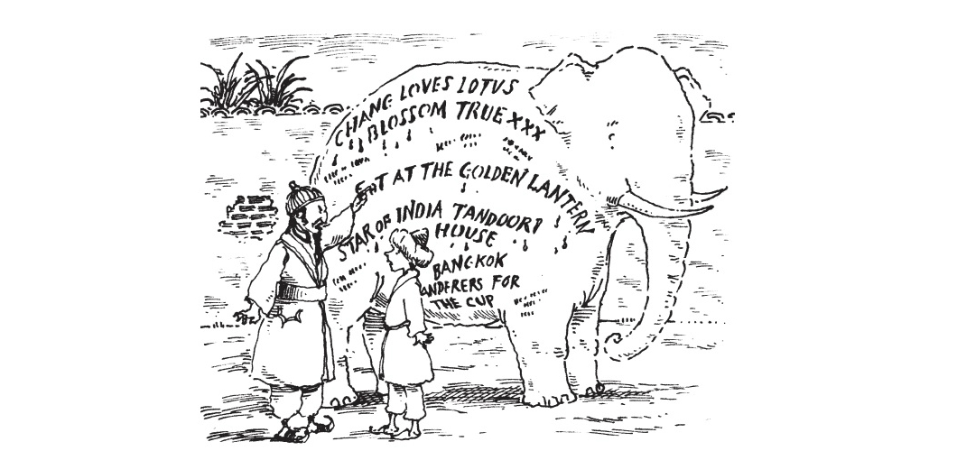
‘I can’t understand how it happens, Master,’ said Chulak. Mind you, the traffic’s awful. I’ve got to watch those rickshaw-drivers like a hawk. I can’t look out for graffiti artists as well – they just slap it up and run.’
‘But Chang loves Lotus Blossom True must have taken a good ten minutes on a stepladder!’
‘Yes, it’s a mystery to me, Master. Shall I clean it off?’
‘All of it! There’s a job coming up in a day or two, and I want this animal clean.’
And the Elephant Master stormed off, leaving Chulak and Lila with the Elephant.
‘Hello, Hamlet,’ said Lila.
‘Hello, Lila,’ said the Elephant. ‘Look what this obnoxious brat has reduced me to! A walking billboard!’
‘Stop fussing,’ said Chulak. ‘Look, we’ve got eighteen rupees already – and ten annas from the Tandoori House – and Chang gave me a whole rupee for letting him write that on the top. We’re nearly there, Hamlet!’
‘The shame!’ said Hamlet, shaking his great head.
‘You mean you charge people money to write on him?’ said Lila.
‘Course!’ said Chulak. ‘It’s dead lucky to write your name on a White Elephant. When we’ve got enough, we’re going to run away. Trouble is, he’s in love with a lady elephant at the Zoo. You ought to see him blush when we go past – like a ton of strawberry ice cream!’
‘She’s called Frangipani,’ said Hamlet mournfully. ‘But she won’t even look at me. And now there’s another job coming up – another poor man to bankrupt. Oh, I hate Turkish Delight! I detest silk sheets! And I loathe gold leaf on my tusks! I wish I was a normal dull grey elephant!’
‘No, you don’t,’ said Chulak. ‘We’ve got plans, Hamlet, remember? I’m teaching him to sing, Lila. We’ll change his name to Luciano Elephanti, and the world’ll be our oyster.’
‘But why are you looking so sad, Lila?’ said Hamlet, as Chulak began to scrub him down.
‘My father won’t tell me the final secret of Firework-Making,’ said Lila. ‘I’ve learned all there is to know about fly-away powder and thunder-grains, and scorpion oil and spark repellent, and glimmer-juice and salts-of-shadow, but there’s something else I need to know, and he won’t tell me.’
‘Tricky,’ said Chulak. ‘Shall I ask him for you?’
‘If he won’t tell me, he certainly won’t tell you,’ said Lila.
‘He won’t know he’s doing it,’ said Chulak. ‘You leave it to me.’
So that evening, after he’d settled Hamlet down for the night, Chulak called at the Firework-Maker’s workshop. It lay down a little winding alley full of crackling smells and pungent noises, between the fried-prawn stall and the batik-painter’s. He found Lalchand in the courtyard under the warm stars, mixing up some red glow-paste.
‘Hello, Chulak,’ said Lalchand. ‘I hear the White Elephant’s going to be presented to Lord Parakit tomorrow. How long d’you think his money’ll last?’
‘A week, I reckon,’ said Chulak. ‘Though you never know – we might run away before then. I’ve nearly enough to get us to India. I thought I might take up Firework-Making when we got there. Nice trade.’
‘Nice trade, my foot!’ said Lalchand. ‘Firework-Making is a sacred art! You need talent and dedication and the favour of the gods before you can become a Firework-Maker. The only thing you’re dedicated to is idleness, you scamp.’
‘How did you become a Firework-Maker, then?’
‘I was apprenticed to my father. And then I had to be tested to see whether I had the Three Gifts.’
‘Oh, the Three Gifts, eh,’ said Chulak, who had no idea what the Three Gifts were. Probably Lila did, he thought. ‘And did you have them?’
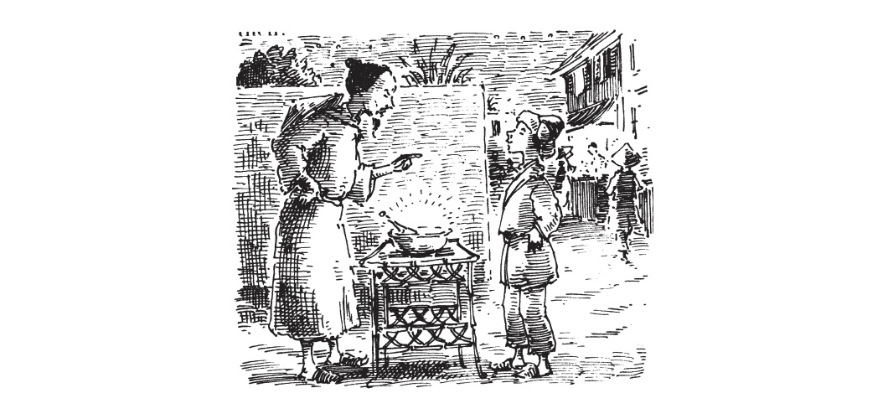
‘Of course I did!’
'And that’s it? Sounds easy. I bet I could pass that test. I’ve got a lot more than three gifts.’
‘Pah! Said Lalchand. ‘That’s not all. Then came the most difficult and dangerous part of the whole apprenticeship. Every Firework-Maker – ’ and he lowered his voice and looked around to make sure no-one was listening – ‘every Firework-Maker has to travel to the Grotto of Razvani, the Fire-Fiend, in the heart of Mount Merapi, and bring back some of the Royal Sulphur. That’s the ingredient that makes the finest fireworks. Without that, no one can ever be a true Firework-Maker.’
‘Ah,’ said Chulak. ‘Royal Sulphur. Mount Merapi. That’s the volcano, isn’t it?’
‘Yes, you pestilential boy, and already I’ve told you far more than I should. This is a secret, you understand?’
‘Of course,’ said Chulak, looking solemn. ‘I can keep a secret.’
And Lalchand had the uneasy feeling that he’d been tricked, though he couldn’t imagine why.

