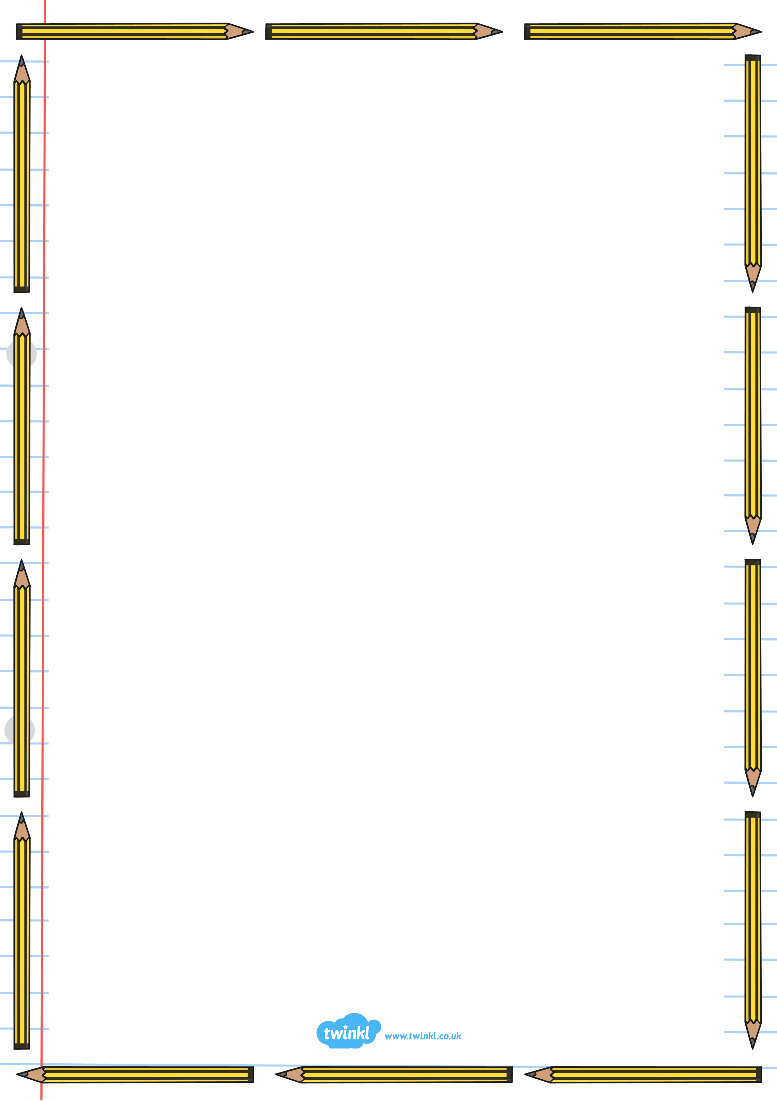

I / we / me – how many times is each word used?

I we me

 Senses

Thoughts

Feelings

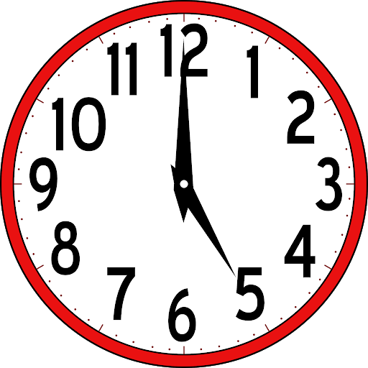 Time words

Toolkit for Writing a Diary

*Write and/or draw examples from The Greedy King’s diary:*