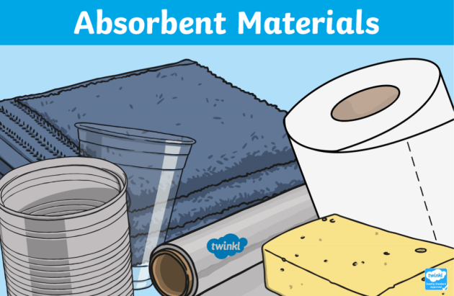
WALT: test the absorbency of materials Date…………………………………………………………..

name of material
waterproof
absorbent

Tell me what you discovered
………………………………………………………………………………………………………………………………………………………………………………………………………………………………………………………………………………………………………………………………………………………………………………………………………………………………………………………………………………………………………………
…………………………………………………………………………………………………………………………………………………………………………………………………………………………………………………………………………………………………………………………………………………………………………………………………………………………………………………………
…………………………………………………………………………………………………………………………………………………………………………………………………………………………………………………………………………………………………………………………………………………………………………………………………………………………………………………………
…………………………………………………………………………………………………………………………………………………………………………………………………………………………………………………………………………………………………………………………………………………………………………………………………………………………………………………………
…………………………………………………………………………………………………………………………………………………………………………………………………………………………………………………………………………………………………………………………………………………………………………………………………………………………………………………………

