JANUARY - Week 2 (w/b 11.1.21)
This week’s overview:
English: Traditional Tales – The 3 Little Pigs, plus ongoing key skills
Spellings: Spellings Spring 2 11.1.21 Please practise these on the sheet in your spelling folder. Remember – your test day is Friday ... good luck! 🍀 Don't forget to let us how you've gone on.
Maths: place value (numbers to 20)
Topics this week: Great Fire of London (history) / Seasons (science)
Phonics Groups:
We have 3 groups for our daily phonics sessions:
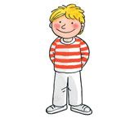Kippers – Mrs. Leavy’s group
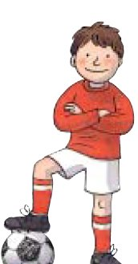 Chips – Miss Platt /Mrs. Tetlow’s group
Biffs – Mrs. Kulczycki’s group

Monday 11th January
English: Today we are starting our new topic – Traditional Tales. Can you find out what traditional means and what a tale is? (Traditional = old, tale = story). Our first traditional tale is the 3 Little Pigs.🐷 🐷🐷 If you have a copy of the book, you can read that if you wish, or you can watch the story here: https://www.youtube.com/watch?v=QLR2pLUsl-Y
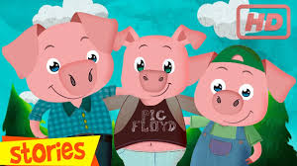
Your first job is to make a story map (just like we did for the story of Harvey Slumfenburger) – just pictures, don’t worry about words! Here is an example if you want to use it. 3LittlePigs.story.map Don’t worry if you don’t have a printer, just split your page up like this and draw the pictures.

11.1.21 The 3 Little Pigs
1. | 2.
3. | 4.
5. | 6.
7. | 8.
Make sure your pictures are nice and clear. You are going to need them tomorrow to help you retell the story! 🐷🐷🐷🐺
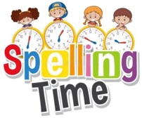🤩 Please spare a little time to practise your spellings - see above. 🤩

Phonics:
Kippers – Mrs. Leavy’s group Mon.2.phase3.y
Chips – Miss Platt /Mrs. Tetlow’s group Mon.2.phase4
Biffs – Mrs. Kulczycki’s group Mon.2.phase5.oy
Maths:
Warm-up – Can you remember how many months there are in a year? Practise them by singing the months of the year song.
https://www.youtube.com/watch?v=Fe9bnYRzFvk
What is the date of your birthday? 🎂 How many days are there in your birthday month?
Task – We are still working on our teen numbers. Can you make your own funky number line (from 11-19)? Collect things (from indoors and/or outdoors)to make each of the numbers e.g. stones, leaves, bottle tops, coins, sweeties etc. *It's best not to use your book for this. Use separate pieces of paper - one for each number.* For example:
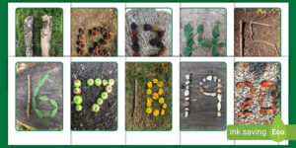Nature Themed Numberline
**Don’t feel you have to complete this in one lesson. Take a bit longer over a couple of sessions if you wish.**
Art (Printing): On Monday, we started our new art topic – printing. Half of the children got to do their handprint printing but then Lockdown came so the other half haven’t done theirs yet. So ... today’s art is to create your own animal handprint – it is up to you which animal you choose and how you decorate it! Here are some examples but there are lots more online. Happy printing!
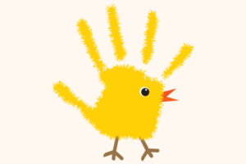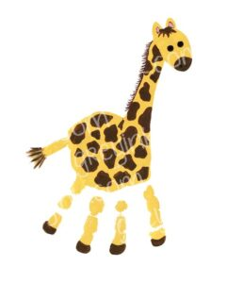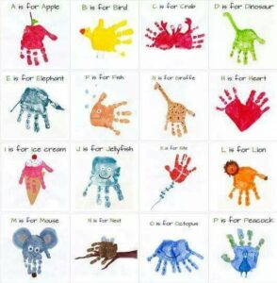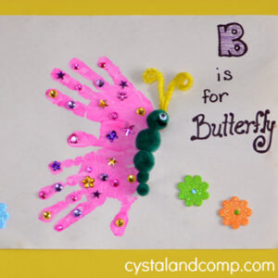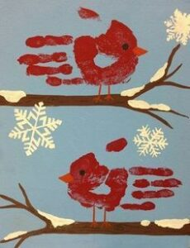
😊 Enjoy your daily reading too - what would you like to read today? 😊

Tuesday 12th January
English: Following on from yesterday’s work, today we are going to retell the story of The Three Little Pigs. We would like you to act out the story using some simple puppets (e.g. stick puppets or finger puppets). These might help: Finger Puppets / Stick Puppets Don’t worry if you don’t have a printer, you can draw your own; no worries if you don’t have lolly sticks, you could use something else like straws or pencils.
To refresh your memory, you can either use yesterday’s story map and/or watch yesterday’s version of the story: https://www.youtube.com/watch?v=QLR2pLUsl-Y Once you have made your puppets, it's time to use them to help you act out the story! Remember to use expression and different voices for each of the characters.
🤩 Please spare a little time to practise your spellings - see above. 🤩
Phonics:
Kippers – Mrs. Leavy’s group Tues.2.phase3.z
Chips – Miss Platt /Mrs. Tetlow’s group Tues.2.phase4
Biffs – Mrs. Kulczycki’s group Tues2.phase5.ir / Tues2.Phase4.blends Train.5 (needed for warm-up)

Maths:
Place Value to 20 - Today we are looking at the video about numbers 11 - 20 (the second video)
Please find the link to the learning today here https://whiterosemaths.com/homelearning/year-1/week-11-number-place-value-within-20/
The warm up is also part of the learning on the video clip.
When the video pauses you will need to complete the sections on the worksheet which is here. Numbers From 11 To 20
Answers can be written on the sheets if you can print them off or written in your books.
Helpful Tips : Draw a number line from 10 to 20 to help you all week and here is a list of numbers together with their number name Number Names To 20
Music: It's music time today! For your warm-up, you will need some pans and one or two wooden spoons (apologies, mums and dads!). Now watch https://www.youtube.com/watch?v=mdKXcKJMF_0&feature=emb_title
Task - today in music we are going to make our own musical instrument. Here are some ideas: https://youtu.be/7sUNXA4NYKI
Have fun! 😄 We look forward to seeing your finished instruments!! 🥁 🎷🎸
✂️ ✂️✂️ Please get a grown-up to help you with any tricky cutting.!✂️✂️✂️
😊 Enjoy your daily reading too - what would you like to read today? 😊

Wednesday 13th January
English: We are still looking at The Three Little Pigs. Today’s work is related to punctuation – the focus is on capital letters and full stops. Please work your way through the Powerpoint: 2. Weds.Three Little Pigs. SPaG. You can write your sentences in your book.
🤩 Please spare a little time to practise your spellings - see above. 🤩
Phonics:
Kippers – Mrs. Leavy’s group Weds.2.phase3.he:she
Chips – Miss Platt /Mrs. Tetlow’s group Weds.2.phase4 / Weds.2.At.the.Seaside.4 (activity)
Biffs – Mrs. Kulczycki’s group Weds2.phase5.keywords
Maths:
Place Value to 20 - Today we are looking at the video about numbers 10s and ones (the third video)
Please find the link to the learning today here https://whiterosemaths.com/homelearning/year-1/week-11-number-place-value-within-20/
The warm up is also part of the learning on the video clip.
When the video pauses you will need to complete the sections on the worksheet which is here. Y1 Autumn Block 4 WO3 Tens And Ones Part 1
Answers can be written on the sheets if you can print them off or written in your books. PLEASE NOTE THIS SHEET OF TASKS RUNS OVER TWO DAYS.
Helpful Tip: If you can't print out the worksheet in order to create the ten frames fold an A4 piece of paper length wise and draw in the squares 😊
Please do not worry about doing all 4 parts. If you manage the first two that's great, complete the rest if your child is confident.
History: Today we’re going back in time to 1666 to find out more about The Great Fire of London. Before we start, can you remember:
🔥 where it started? (It started in a bakery on Pudding Lane in London.)
🔥 when it started? (Sunday 2nd September 1666).
Today’s key questions are:
🔥 How did the fire start and how long did it last?
🔥 Why did the fire spread so quickly?
To help us to answer these questions, we are going to ‘visit’ The Museum of London to learn all about how the fire began! 🔥🔥🔥 The link below takes us to the museum. It says ‘live stream’ but it has been pre-recorded. There are points in the video where you are given time to think; if you have finished your ‘discussions’ before the thinking time is up, please feel free to skip on.
https://www.museumoflondon.org.uk/families/great-fire-london-live-stream/part-1
You need to watch up to 9:30 mins as this contains the key information to help us to answer our questions.
9:30 mins. - 12:35 mins: Thinking Time – please talk to a grown up and come up with a a couple of questions of your own.
12.35 – 24:55: There is a Q & A session now– it‘s just over 12 minutes long but it is worth a watch. I learned some new things that I didn’t know! It is up to you how much of it you watch but it does teach us some interesting facts e.g. Did you know that the fire destroyed almost a quarter of London at the time?
Skip to 26:21 mins: Task – Think about why fire spread so quickly. To help you with this, you might want to re-watch 3:55 mins – 9.30mins. Now complete the activity: How Did The Fire Spread So Quickly? Don’t worry if you don’t have a printer; you can make your work into a poster (just draw your pictures in your book and write the labels).
😊 Enjoy your daily reading too - what would you like to read today? 😊

Thursday 14th January
English: We are still looking at The Three Little Pigs. Today’s work is related to grammar – today the focus is on using and to join ideas. Please work your way through the PowerPoint: 2. Thurs.Three Little Pigs. SPaGII You can write the sentences you make in your book.
🤩 Please spare a little time to practise your spellings - see above. 🤩
Phonics:
Kippers – Mrs. Leavy’s group Thurs.2.phase3 14.1.21
Chips – Miss Platt /Mrs. Tetlow’s group Thurs.2.phase4 (1)
Biffs – Mrs. Kulczycki’s group Thurs2.phase5 .oe Au
Maths:
Place Value to 20 - Today we are looking at the video about numbers 10s and ones (the fourth video)
Please find the link to the learning today here https://whiterosemaths.com/homelearning/year-1/week-11-number-place-value-within-20/
The warm up is also part of the learning on the video clip.
When the video pauses you will need to complete the sections on the worksheet which are here. Y1 Autumn Block 4 WO3 Tens And Ones Part 2
Answers can be written on the sheets if you can print them off or written in your books.
Helpful Tip: If you can't print out the worksheet in order to create the ten frames fold an A4 piece of paper length wise and draw in the squares 😊 Instead of counters you can use coins, buttons etc.
Please do not worry about doing all 5 parts. If you manage the first two that's great, complete the rest if your child is confident.
Science:
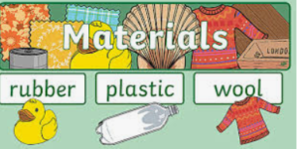

We are starting a new topic today all about different materials.
Lesson 1 - What is a material?
Watch the video here https://classroom.thenational.academy/lessons/what-is-a-material-74u30t?step=1&activity=video and when the video pauses you will need to complete the sections on the worksheet, which is here Materials
What materials you can find in your home? If you have time go on a material hunt! 😊
😊 Enjoy your daily reading too - what would you like to read today? 😊

Friday 15th January
English: Watch The Three Little Pigs one last time: https://www.youtube.com/watch?v=QLR2pLUsl-Y
Today you are going to retell the story in your own words. Please have a ‘good go’ at using ‘and’ to join your ideas. Think about the work that we have done earlier in the week (see Fri.writing Checklist) ... that should help! Please complete the correct activity for your group:
Kippers – 3LittlePigs.Kippers
Chips – 3LittlePigs.Chips
Biffs – 3LittlePigs.Biffs
Don't worry if you don't have a printer; instead, write the sentences in your book (if you wish, you can draw pictures too).
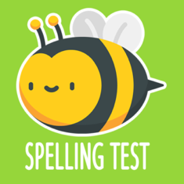 🍀🍀🍀 Good luck with your spelling test 🍀🍀🍀

Phonics:
Kippers – Mrs. Leavy’s group Fri.2.phase3 15.1.21
Chips – Miss Platt /Mrs. Tetlow’s group
Today we are going to watch a live video on consonant blends that we have been looking at this week. https://www.youtube.com/watch?v=66VrNnJSDPw&feature=youtu.be
Biffs – Mrs. Kulczycki’s group - Today we are learning a new sound and it is ey
Take a look at this short video https://www.youtube.com/watch?v=jua0OODatow
Now complete our tasks using Phonics Play Fri2.phase5 Ey

Maths:
Place Value to 20 - Today we are looking at the video about 1 more and 1 less (the fifth video)
Please find the link to the learning today here https://whiterosemaths.com/homelearning/year-1/week-11-number-place-value-within-20/
The warm up is also part of the learning on the video clip.
When the video pauses you will need to complete the sections on the worksheet which are here. One More And One Less
Answers can be written on the sheets if you can print them off or written in your books.
Helpful Tip: Use real objects to help you count if that helps and don't forget to use your number line!
Computing: What is an algorithm?
An algorithm is a list of rules to follow in order to solve a problem.
Algorithms need to have their steps in the right order. Think about an algorithm for getting dressed in the morning. What if you put on your coat before your jumper? Your jumper would be on top of your coat and that would be silly! When you write an algorithm the order of the instructions is very important.
Watch this video and find out what algorithms are. https://www.bbc.co.uk/bitesize/topics/z3tbwmn/articles/z3whpv4
Your challenge now is to make a jam sandwich. Take a look at this power point to help you make it in the correct order T C 7834 How To Make A Jam Sandwich Powerpoint Ver 1 (1)
Now that you have made your sandwich, can you remember the correct order you made it in? I hope you enjoyed it. 😊
Your challenge is now to put these pictures in the right order to complete your algorithm successfully T T 29092 Jam Sandwich Sequencing Activity Sheet Activity Sheet Ver 1

😊 Enjoy your daily reading too - what would you like to read today? 😊

