www.phonicsplay.co.uk
See Y1 homepage for login details

Fri.7/i_e 2 (bike)

Warm-up (revision) – Log onto Phonics Play - today we are going to play:
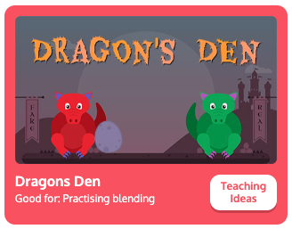
Choose (Phase 5). Are the i_e words real or nonsense? Sort them. How did you get on?

* Today we are learning more about yesterday’s new grapheme i_e and how to read and write it.*

Watch the rest of yesterday’s Letters and Sounds lesson (i_e). Start the clip at 15:59 mins:
https://www.youtube.com/watch?v=UQBFigKD7j4&feature=youtu.be

Task 1: Read the sentences below, then write the i_e words from each sentence in your book:
Will you invite me inside?

Can a slide shine all the time?

Is it time to get my nice prize yet?

Task 2: Now complete the i_e read & spell activity – see today’s resources.
*As you spot the words in the wordsearch, write them on the list on the left-hand-side of the page.*

Well done Biffs – keep it up!

