www.phonicsplay.co.uk
See Y1 homepage for login details

Mon.7/a_e (make)

Warm-up (revision) – Log onto Phonics Play - we are going to play . Choose . How did you get on?

Today we are starting our new group of phonemes – split digraphs.

A split digraph contains two letters (a_e, e_e, i_e, o_e and u_e) but they are split between a consonant, for example; make, bike and tube.
The split digraph works by using an ‘e’ after the initial vowel to change the sound of the vowel. With a split digraph, not becomes note, hug becomes huge etc.
Note the change in the sound of the first vowel from a hard sound to a longer softer sound, this is because of the ‘e’. There are five split digraphs; a_e, e_e, i_e, o_e and u_e.

Note for parents – you might want to watch this short clip first:
https://www.twinkl.co.uk/teaching-wiki/split-digraph

Now, as a nice introduction, listen to the song below:
https://www.youtube.com/watch?v=bZhl6YcrxZQ

* Today we are learning a new grapheme a_e and how to read it.*

Watch today’s Letters and Sounds lesson (a_e):
https://www.youtube.com/watch?v=5CAQ1VtHrqI&feature=youtu.be
*Stop the lesson after 15:37 mins. We will watch the rest tomorrow.*

Task: Read the a_e words in the word wall below:
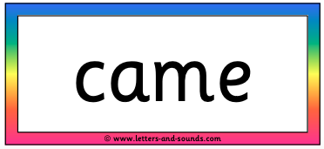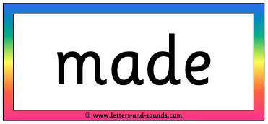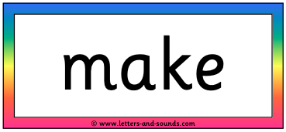
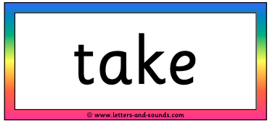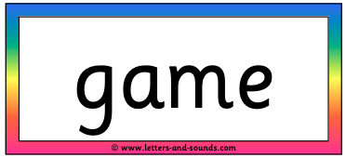
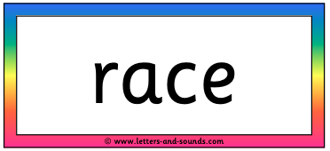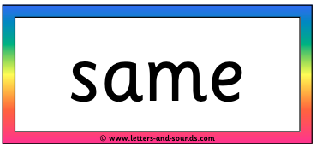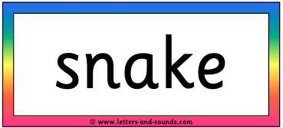
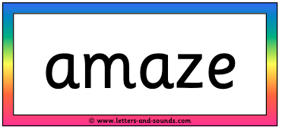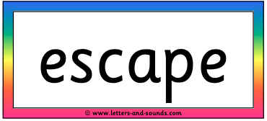
Well done Biffs – keep it up!

