www.phonicsplay.co.uk
See Y1 homepage for login details

Our Chips are doing well and are now ready to start Phase 5 phonics!

How Phase 5 works:
Children entering Phase Five should be able to read and spell words containing adjacent consonants (e.g help, twin) and some polysyllabic words (e.g. window, sister). The purpose of this phase is for children to broaden their knowledge of graphemes and phonemes for use in reading and spelling.

Mon.7/ay

* We are learning a new grapheme ay and how to read and write it.*
Watch Letters and Sounds lesson: ay
https://www.youtube.com/watch?v=6AiVFK9SMj0&feature=youtu.be
You will need a pencil and your book because part-way through, you will be asked to write some of your words down.

Task 1 – Can you read these ay words?
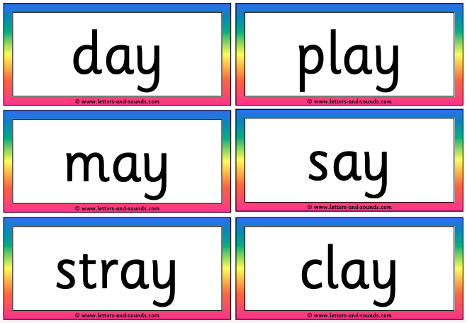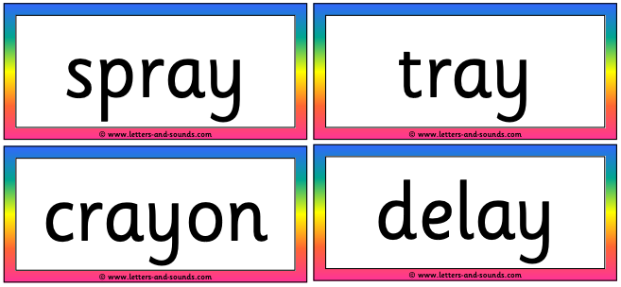

Task 2 – Ask an adult to read this sentence aloud:
I went on holiday in May.
Write the sentence and underline the ay words with a ruler. Draw a picture to match your sentence.

Well done Chips – a good first job with Phase 5!

