www.phonicsplay.co.uk
See Y1 homepage for login details

Thurs.7/i_e (bike)

Warm-up (revision) – Play the Yes / No Yeti game on Phonics Bloom (no login needed). https://www.phonicsbloom.com/uk/game/yes-no-yeti?phase=5
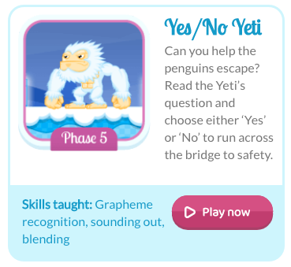

* Today we are learning a new grapheme i_e and how to read it.*

Watch today’s Letters and Sounds lesson (i_e):
https://www.youtube.com/watch?v=UQBFigKD7j4&feature=youtu.be
*Stop the lesson after 15:58 mins. We will watch the rest tomorrow.*

Task 1: Read the i_e words in the word wall below:
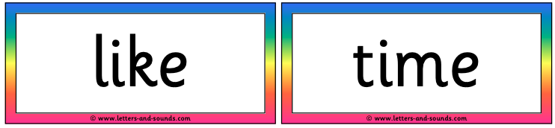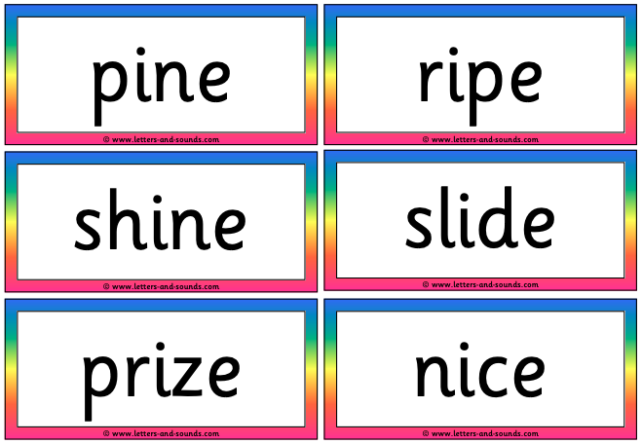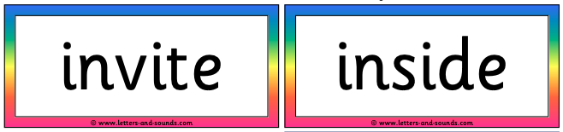

Task 2: Read you the sentences below. Make sure you can see the word wall above – the answers to the missing words are all in there .
Choose i_e words from the word wall above to complete each sentence. Only write the i_e word, not the full sentence!
e.g. I hope the sun will ___________ tomorrow.
shine

- What ________ is it, Mr. Wolf?
- He said he would _________ me to his birthday party.
- When I came first in the race, I won a __________.
- It was raining again so we had to play ___________.
- I went on a hunt in the forest and found eight __________ cones.

Well done Biffs – keep it up!

