www.phonicsplay.co.uk
See Y1 homepage for login details
Thurs.7/oy

* We are learning a new grapheme oy and how to read and write it.*
Watch Letters and Sounds lesson: oy
https://www.youtube.com/watch?v=6_33f0rHkFg&feature=youtu.be

Task 1 – Can you read these oy words?
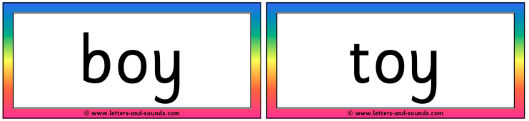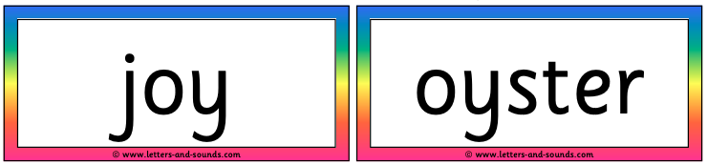
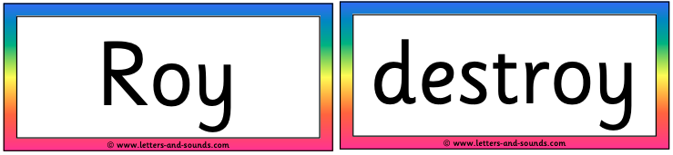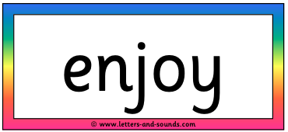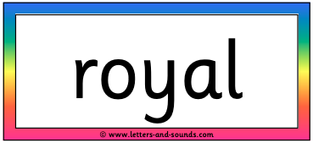

Task 2 – Today you are going to be detectives! Can you find the oy words hidden in the picture? Make a list of them in your book. Highlight each oy in a colour e.g. royal.

Well done Chips - great job with oy!

