www.phonicsplay.co.uk
See Y1 homepage for login details

Mon.7/a_e (make)

Warm-up (revision) – Log onto Phonics Play - today we are going to play:
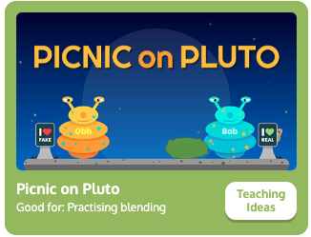
Choose (Phase 5). Are the a_e words real or nonsense? Sort them. How did you get on?

* Today we are learning more about yesterday’s new grapheme a_e and how to read and write it.*

Watch the rest of yesterday’s Letters and Sounds lesson (a_e). Start the clip at 15:37 mins:
https://www.youtube.com/watch?v=5CAQ1VtHrqI&feature=youtu.be

Task 1: Read the sentences below, then write the a_e words from each sentence in your book:
It will amaze me if you can escape from this maze.
When the Romans came to invade, they made long roads.
Can a snake have a race with a whale in a lake?

Task 2: Now complete the a_e read & write activity – see today’s resources.

Well done Biffs – keep it up!

