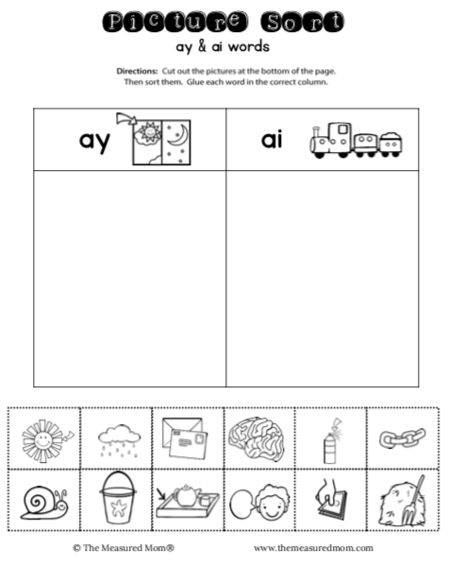

Now write a label for each of the pictures in the correct column too

e.g. ch**ai**n in the ai column, r**ay** in the ay column.