www.phonicsplay.co.uk
See Y1 homepage for login details

Weds.7/trickywords x3

Warm-up (revision) – Log onto Phonics Play then read the story. Remember to click the pictures to see what happens!
https://www.phonicsplay.co.uk/resources/phase/4/interactive-story-book

Today we are learning to read the tricky words:
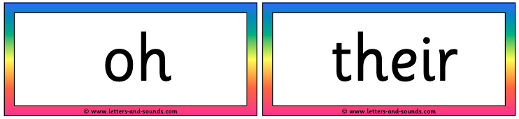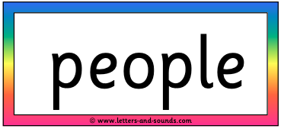
Task 1 – To help us to learn these words, play the Train your Brain game on Phonics Play:
https://www.phonicsplay.co.uk/resources/phase/5/train-your-brain-ph5
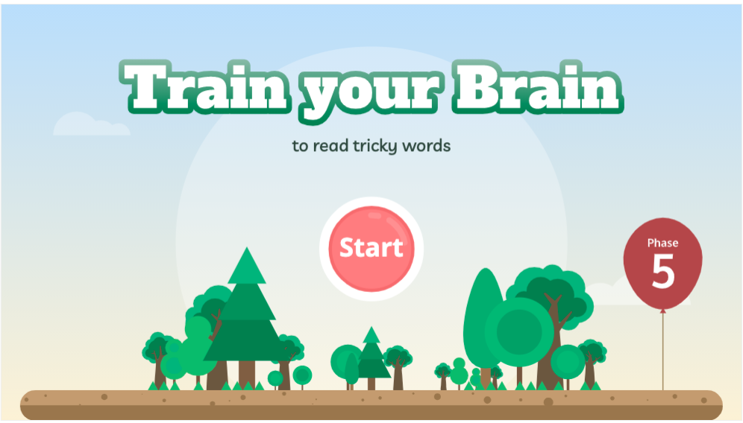
Follow the instructions. When it comes to choosing the words, select each of our 3 words form the list below:
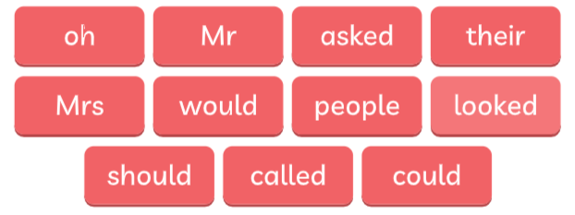
First click the Sound Buttons, then the Tricky Bits. This should help us to read the words.
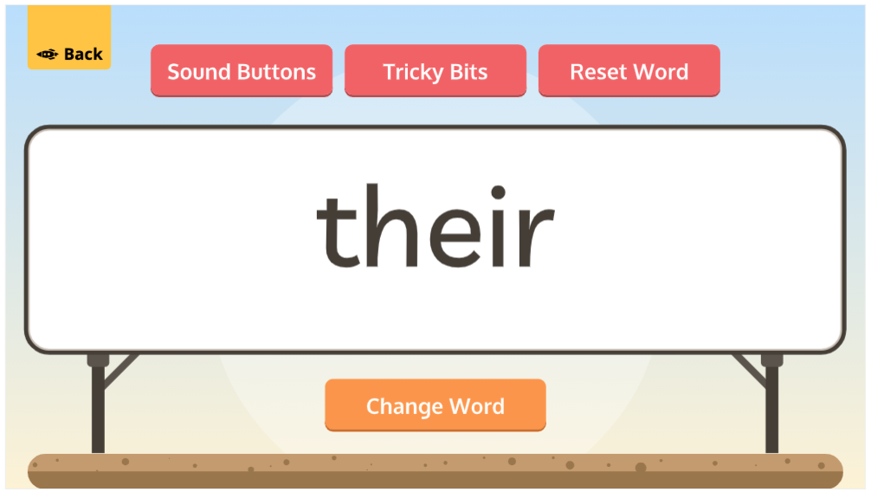

Task 2 – Now read the words below as fast as you can:
oh | people | their | oh
their | their | people | their
people | oh | oh | their
oh | people | their | people
people | oh | people | their
their | their | oh | people
Task 3 – Read the sentences below … can you spot our key words?
Some people play loud sounds on horns.
Oh! I found a crayon.
Do people eat their sprouts?
Now copy each sentence carefully into your book. With a ruler, underline our key words – oh, people, their.

Well done again Chips!

