www.phonicsplay.co.uk
See Y1 homepage for login details

Weds.7/keywords x4

Warm-up (revision) – Log onto Phonics Play:
https://www.phonicsplay.co.uk/resources/phase/4/reading-robot
Then choose . Read the words. How did you do?
* Today we are learning to read the key words:
some come
were there
What do we notice about how the pairs of words are spelt?

Task 1 – It’s detective time! You need to be logged onto Phonics Play. Click on https://www.phonicsplay.co.uk/resources/phase/5/sentences-5a
Click Start then to take you onto Page 2, where you’ll need Week4/Wednesday:
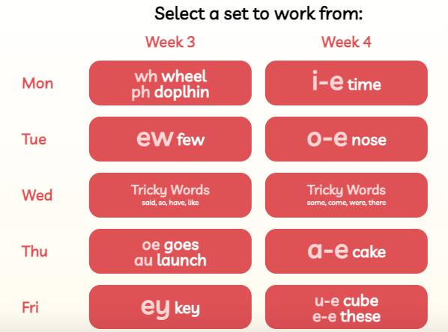
Read each sentence. Can you spot today’s key words?

Task 2 – Ask an adult to read you the sentences below i.e the ones we’ve just read. Write them carefully in your book or on a white board … don’t forget to sound talk!
Some dolphins come home to sleep.
Were there lots of donkeys on the beach?
Were there some turkeys on the lawn?
With a ruler, now underline some / come / were / there.

Great work with your key words, Biffs!

