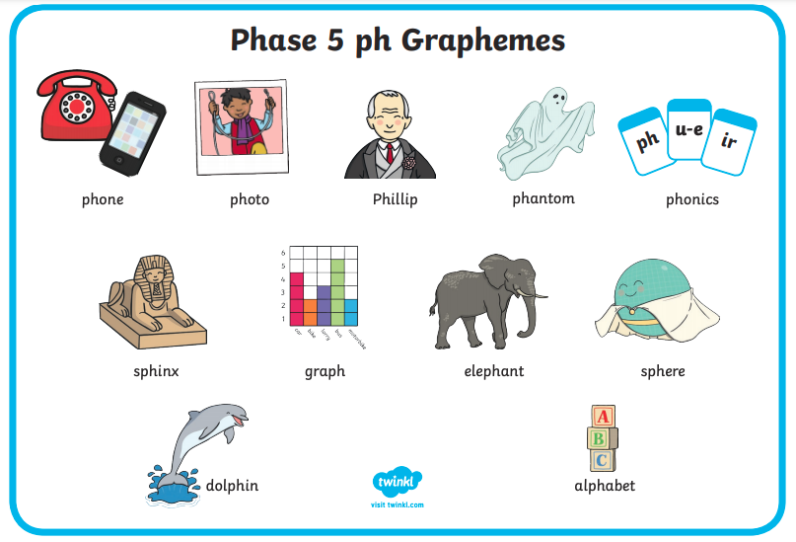

e.g..

7.

1.

4.

Clue for number 6. …

It’s the name of a 3d shape!

6.

5.

8.

3.

2.

Write a label for each ph picture.

**Word bank**