www.phonicsplay.co.uk
See Y1 homepage for login details

Thurs.8/ph

* We are learning a new grapheme ph and how to read and write it.*
Watch Letters and Sounds lesson: ph
https://www.youtube.com/watch?v=JNaUCoWd9e8&feature=youtu.be
You will need a pencil and your book because part-way through, you will be asked to write some of your words down.

Task 1 – Can you read these ph words?
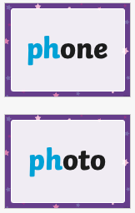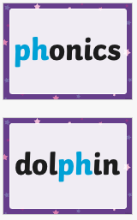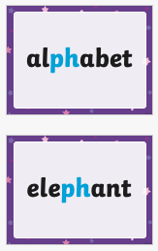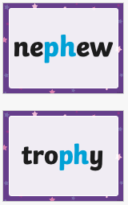

Task 2 – Complete the ph word bank (see today’s resources) by writing the ph word to match each picture.
Don’t worry if you don’t have a printer, just make a list of the words in your book. Don’t forget to number them from 1. to 8.

Well done Chips – super Phase 5 work!

