www.phonicsplay.co.uk
See Y1 homepage for login details
Fri.8/u_e 2 (cute)

Warm-up (revision) – We’ve now come to the end of Phase 5a . Let’s revise all our Phase 5 phonemes by playing the Popping Balloons PowerPoint game (see today’s resources).
Pop the balloons as you name the phonemes.
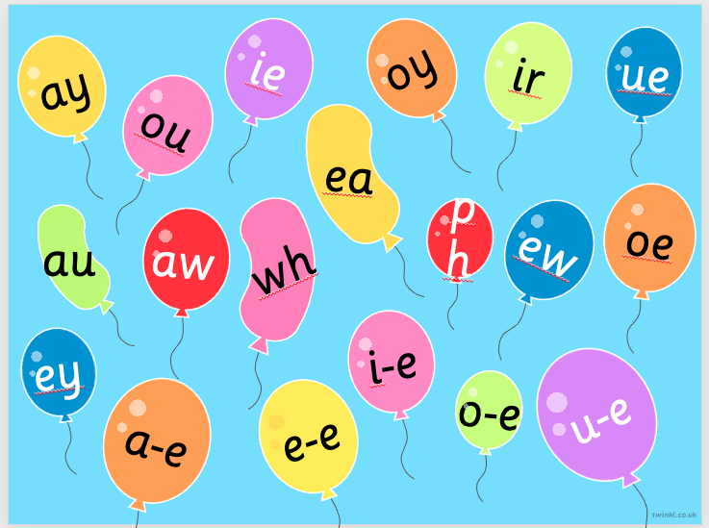
To play the PowerPoint, click Slide Show then Play from Start.
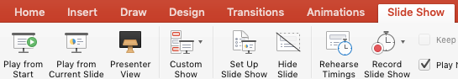

PTO

* Today we are learning more about yesterday’s grapheme u_e and how to read and write it.*

Watch the rest of yesterday’s Letters and Sounds lesson (u_e). * Start the lesson at 17:50 mins.
https://www.youtube.com/watch?v=xspQiDw0lDk&feature=youtu.be

Task : Now play the interactive spelling u_e game on Galactic Phonics.
Don’t forget that the digraph is split u _ e!
https://games.galacticphonics.com/longvowels/u-e/interactive/uespell/uespellt.htm
Good luck! How many do you score?

Well done Biffs – keep it up!

