www.phonicsplay.co.uk
See Y1 homepage for login details

Mon.8/ie

* We are learning a new grapheme ie and how to read and write it.*
Watch Letters and Sounds lesson: ie
https://www.youtube.com/watch?v=YXDmTeSkCrU&feature=youtu.be
You will need a pencil and your book because part-way through, you will be asked to write some of your words down.

Task 1 – Can you read these ie words?
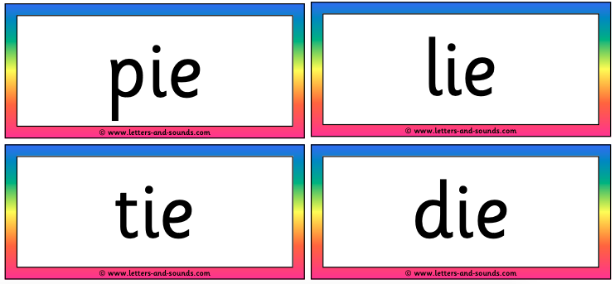
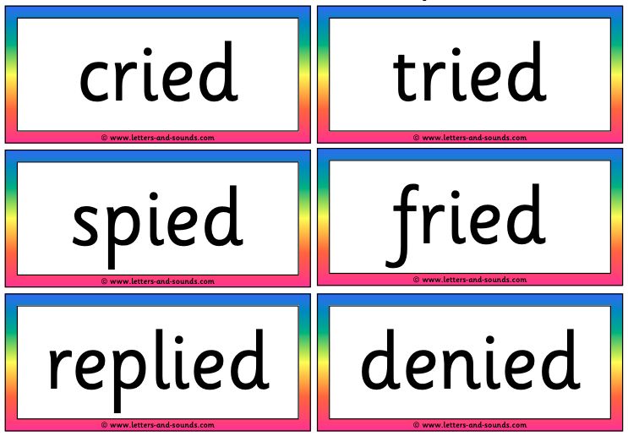

Task 2 – Read these sentences and highlight each of the ie words. Make a list of all the ie words you find in your book.
Oh no, I spied a fried pie.
People denied that they had cried.
She replied that their cat had tried to run up the tree!
Well done Chips – super Phase 5 work!

