www.phonicsplay.co.uk
See Y1 homepage for login details

Mon.8/o_e (woke)

Warm-up (revision) – Log onto Phonics Play - we are going to play 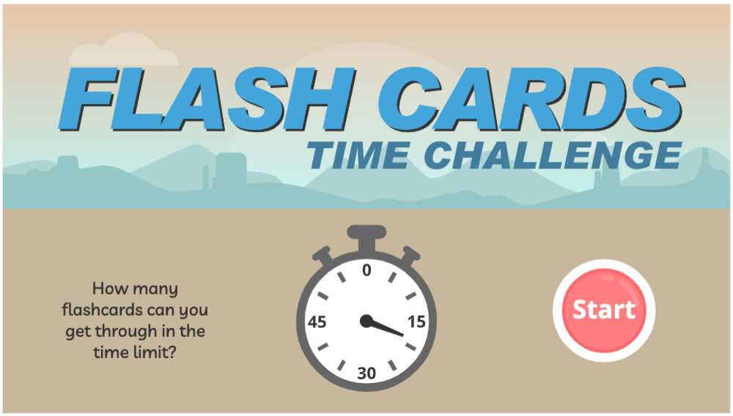.
https://www.phonicsplay.co.uk/resources/phase/5/flashcards-time-challenge

Choose . How did you get on? What split digraphs did you spot?

* Today we are continuing with split digraphs;
we are learning a new grapheme o_e and how to read it.*

Watch today’s Letters and Sounds lesson (o_e):
https://www.youtube.com/watch?v=HOajky46znQ&feature=youtu.be

* Stop the lesson after 14:20 mins. *
We will watch the rest of the lesson tomorrow.

Task: Read the o_e words in the sentences below. Highlight all the o_e words you see. You can work with a partner or alone!

- The smoke rose from the old stove.
- The people found a dinosaur bone on their way up the slope.
- Can a shiny stone explode?
- When he was alone, he chose to speak on the phone.
- I hope to find a skipping rope in the loft of my new home, she said.
- Have you ever seen the queen on the throne or on an envelope?

Well done Biffs – keep up the great work!

