www.phonicsplay.co.uk
See Y1 homepage for login details

Thurs.8/u_e (cute)

Warm-up (revision) – Log onto Phonics Play - we are going to play
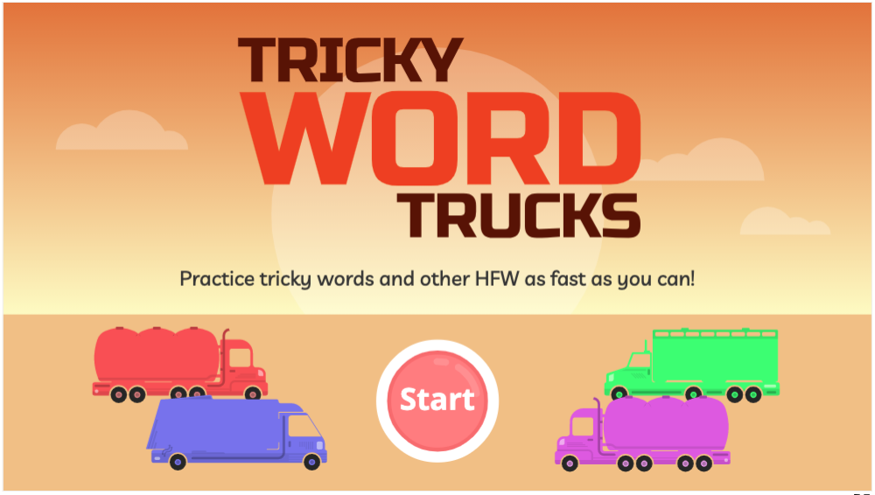.
https://www.phonicsplay.co.uk/resources/phase/5/tricky-word-trucks
Choose . There are some tricky ones that are from Phase 5b too. How did you get on?

* Today we are continuing with split digraphs;
we are learning a new grapheme u_e and how to read it.*

Watch today’s Letters and Sounds lesson (u_e):
https://www.youtube.com/watch?v=xspQiDw0lDk&feature=youtu.be

* Start the lesson at 6:43 mins. *
* Stop the lesson at 17:50 mins.
We’ll watch the rest of the lesson tomorrow.
Have you noticed how u_e makes two sounds?
* u_e as in rude makes an oo sound *
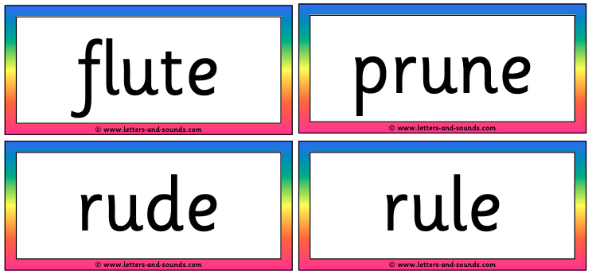
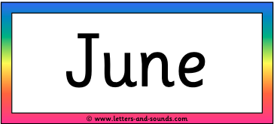

* u_e as in tube makes more of a you sound *
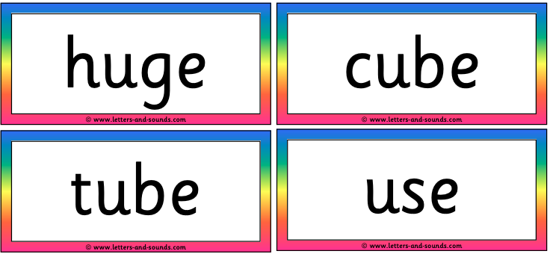
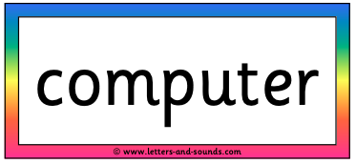
Task: Now complete the u_e read and spell activity (see today’s resources).
- First, read the words in the grid.

- Next, cover them up and see how many you can find in the wordsearch. No peeking !!!

- As you find a word, colour it in in the wordsearch, then write it twice in the grid – in Write & Check columns 1 and 2.

** Can you find them all? **

Well done Biffs – keep up the great work!

